https://www.lakeheadu.ca/assets/lkh.png

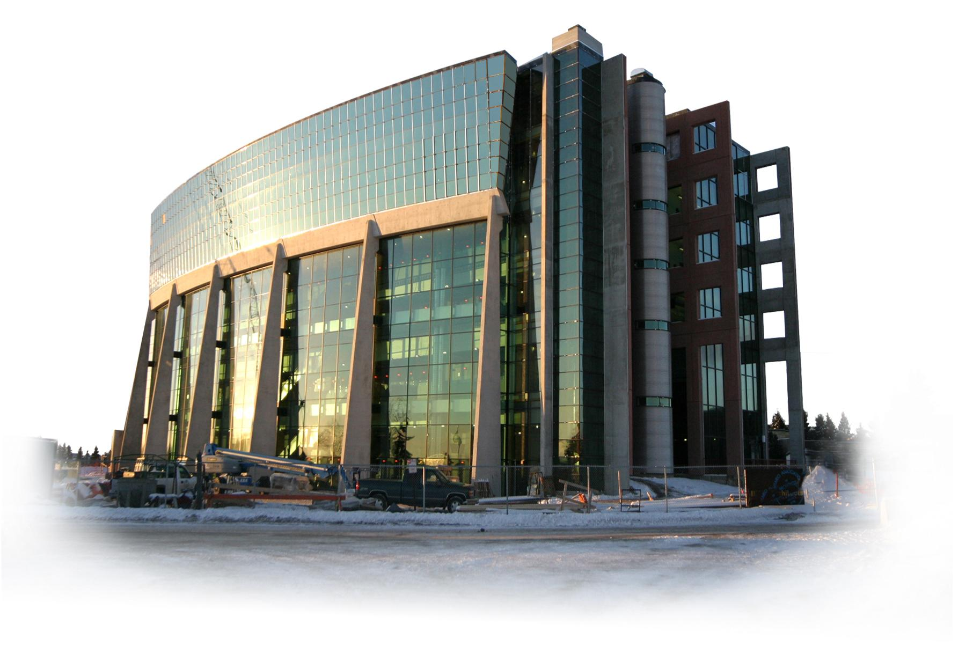

**As instruments of communication and**

**discovery, languages**

**open a window on the**

**diversity of the human**

**experience.**

**Department**

**of**

**Languages**

[**http://languages.lakeheadu.ca**](http://languages.lakeheadu.ca)

https://www.lakeheadu.ca/assets/lkh.png

955 Oliver Road,

Thunder Bay, Ontario, Canada, P7B 5E1

Reasons to become fluent in another language

• The acquisition of other languages, while providing the student with a competitive edge on the job market, will allow him/her to better understand other people and cultures.

• The mastery of a second-language has always been considered a desirable part of any education. Not only is it a tool to establish and develop communication but it is through the knowledge of a language that one can really comprehend the subtleties conveyed by its culture.

Why study Languages at Lakehead?

• Small classes and low student/teacher ratio

• All language courses are taught in the target language

• Student learning centered approach

• Open-door policy for support, advice, help and tutorials

• Availability of helpful monitors whose mother-tongue is one of the languages taught

• All members of the Department have extensive cultural experience and are involved in research in various fields including, literature, linguistics and education.

• Availability of a Computer Assisted Language Learning Centre to take full advantage of new multi-media technologies.

f-banner

f-banner

For further information,

please contact:

**Dr. Béatrice Vernier**

**(Chair)**

**Tel: (807) 343-8620**

bvernier@lakeheadu.ca

**Administrative assistant**

**Anita Fragale**

**Tel: (807) 343-8261**

aifragal@keheadu.ca

<http://languages.lakeheadu.ca>

What careers are open to language students?

It is natural to associate language studies with a career in education (primary and secondary schools; colleges, universities) or in interpretation / translation.

However, opportunities for language professionals abound in many other fields.

**Why not become an Archivist, a Court Interpreter, a Journalist, a Museum Curator or a Scientific Translator?**

In fact, students come to our Department from every field because there is virtually no career or profession in which the ability to speak another language is not an advantage or a necessity. Government agencies, business, health sciences and industry are becoming increasingly aware of the advantages of hiring employees who have a solid base in languages..

**Have you ever thought of becoming a:**

• International Trade Economist

• Speech Therapist

• Social Worker

• Hotel Administrator

• Tourism Operator?

**How about a foreign:**

• Diplomat

• Correspondent?

f-banner

f-banner

Frequently Asked Questions...

**Do I meet the requirements to register in a French Major Program?**

**Grade 12** standing is the **normal requirement** (Core French or French Immersion) to register in a French degree program. If you have not completed your Grade 12 requirements, **the Department offers** on a regular basis “**Elementary French” (Grade 9 required)** and “**French for Beginners”**.

Our Concurrent Program in French and Education (**BABed, HBABed)** is designed for those students who wish to pursue a career in teaching French at the elementary or secondary levels. The concurrent program, i.e., majoring in French and Education gives students two excellent degrees toward becoming French teachers in Ontario. Even a minor concentration in French and a specialization in another field will enhance your chances of employment as a teacher.

**I am registered in another discipline. Is there any possibility for me to improve my knowledge of other languages?**

Yes, the Department offers a Minor in Finnish, FrenchItalian, Ojibwe, Spanish as well as a Certificate of French Proficiency or an Aboriginal Languages Specialist’s Certificate.

**For details on the different programs and courses available, please consult the Lakehead University Calendar available at:**

**Mycoursecalendar.lakeheadu.ca**

f-banner

Welcome \ Bienvenue

Willkommen \ Bienvenidos

Tervetuloa \ Benvenuti

## The Department of Languages provides students the opportunity to achieve an advanced level of competency in a number of languages. It introduces them to various cultures, promoting both the acquisition of knowledge and the development of communication skills and critical thinking in a creative learning environment.

Programs Offered

Our Department offers four major programs in **French** **(BA; HBA; BABEd; HBABEd)**, as well as the possibility of completing double majors (French/History, English/French, French/Philosophy). A minor in **Classics**, a **Certificate of French Proficiency**, an **Aboriginal Languages Specialist's Certificate** are also offered.

Finnish, French, German, Italian, Mandarin and Spanish are offered at the introductory level.

Students have several opportunities for immersion in French surroundings:

**- Immersion course in Québec**

**- Exchange program with a French University**

**- Summer employment in Québec**

**- Position as an English assistant in a school in France**

f-banner