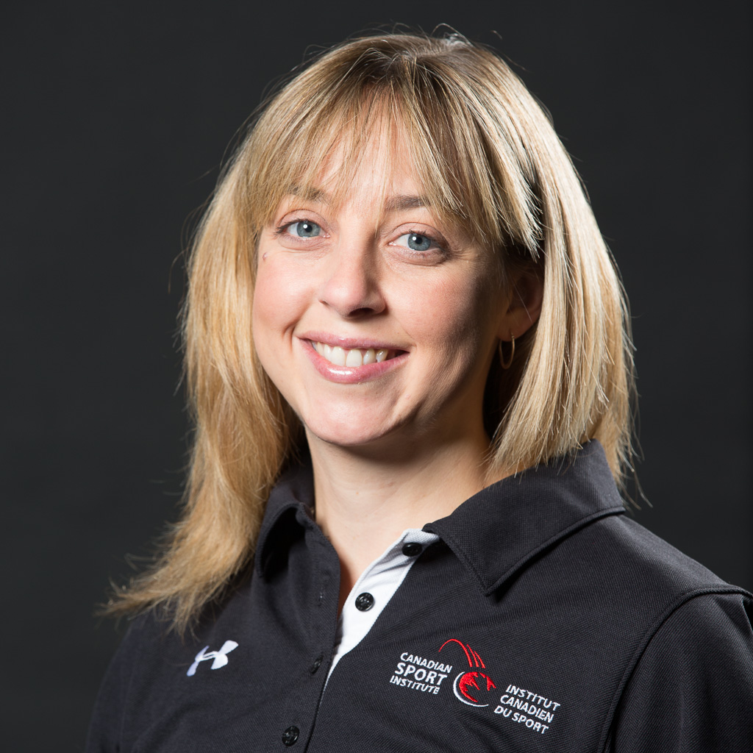
Erin Sargent
HBKin Grad 1998

My career has evolved since graduation but my success was built on the great foundation I received in the Kinesiology program at Lakehead. Shortly after graduation, I started a personal training business in Thunder Bay. I was one of very few females working in the field as a personal trainer in Thunder Bay at that time. It was this experience which solidified that I wanted to always work in an applied setting. My venture proved to be very successful and by the 2nd year, I had a waiting list for taking new clients. By the 3rd year, I realized that I wanted to study further while staying in an applied setting so I chose to return to the University of Calgary for their Masters of Kinesiology (MKin) program.

While studying in Calgary, I continued to train clients part-time. While applying for part-time work, I was told on two occasions that any employees that were graduates of Lakehead’s Kinesiology program were some of their best! I attributed this to the practical courses and skill-based labs that were woven throughout the 4 years of curriculum.

The MKin program was course-based and included a research component. They were two of the hardest years of my life but proved very valuable. My skills and knowledge were advanced, I had many opportunities to work in the field with elite athletes and my confidence grew. Some of my time spent in the program required me to be a TA and I discovered that what I loved the most at that time was to teach. Following graduation, I returned to Lakehead to teach for one semester in the lab before securing a sessional teaching position at Humber College in the Fitness and Health Promotion (FHP) Program. This 2-year diploma program was designed to train students to work as personal trainers and in public health. Although I loved teaching at the Humber, Toronto was not for me. Fortunately, a position was posted for a full-time, permanent position as a professor at Niagara College in the same program.

I taught in the FHP program for 8 years, all the while realizing that there was a need in the Niagara Region for more qualified Certified Exercise Physiologists and Kinesiologists. To respond to that need, myself, along with a colleague, developed the Exercise Science for Health and Performance Program. This is a one year graduate certificate designed for Kinesiology grads that need to build their practical skills and knowledge to feel confident and be successful in their field. With the new designation of “Registered Kinesiologist” in Ontario, the timing was ideal. The program has improved its enrollment each year since its inception. During my time at the college, I dabbled in the field to ensure my own skills were up to par. However, by the 10-year mark, I felt a pull to return to my field.

I do believe opportunities present themselves at the right time. A position for an Exercise Physiologist was posted at the Canadian Sport Institute in Calgary (CSI Calgary) just as I was feeling this need to return to the field. I would be working with my MKin professor from U of C and a few of my former classmates. I jumped at the chance to move when I was offered the position and I have now been with CSI Calgary for over a year. It gets better every day. I am responsible for a number of National and Development teams when it comes to assessment and interpretation. I also work closely with both the NextGen and National Wrestling athletes as part of the Integrated Support Team where I am responsible for cardiovascular programming. The Canadian Sledge Hockey Team is another group that I love to work with. And finally, I am the lead Anthropometrist for our National Teams. I may return to teaching one day in the future and I know that this experience would prove valuable in the classroom.

I can’t say enough about the strong foundation that I received at Lakehead. It was there that I developed the passion for sport and recognized the need for being a lifelong learner. I wish there was enough time in the day to read all the research related to my field! You should be proud to be a Kinesiology grad from Lakehead.

