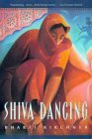[](http://www.bookmag.net/v2/wp-content/uploads/2013/05/leaveittome.jpg)[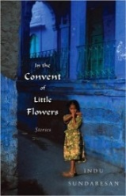](http://fictionwritersreview.com/wp-content/uploads/convent.jpg)

DATE:

NOV. 9, 2015

TIME:

12:30-1:30PM

WHERE:

ATAC 3004

**Transnational Adoption in Diasporic Indian Women’s Writing: Re-figuring Maternity, Belonging and Nation**



*Holly Morgan is an instructor in the Department of Women’s Studies at Lakehead University*

**with Holly Morgan, PhD candidate**

**Brown Bag Speaker Series**

**Lakehead Women’s Studies**