<Text in blue is provided for informational purposes only and should be deleted when writing your Standard Operating Procedure (SOP). This document is intended as a guideline and should be used as inspiration. A separate SOP is required for each laser in the lab.>

I. SCOPE

<Provide a brief description of the work described in the procedure. Include relevant history on the method.>

II. PURPOSE

<Describe briefly what this procedure should accomplish>

III. HAZARDS

<Describe all potential consequences of misuse of the equipment in the procedure. Ex: Hazards to eyes, hazards to skin, electrical hazards, etc >

IV. RESPONSIBILITIES

<Identify all stakeholders and their responsibilities. Stakeholders could include, but are not limited to; Supervisors, Workers, Students, Environmental Health and Safety etc.>

V. LASER DESCRIPION

<Describe the equipment and all details relevant to laser use that are applicable including but not limited to :hazard classification, lasing medium, beam divergence, aperture diameter, pulse length, pulse energy, repetition rate, maximum output power, wavelengths range. The laser or laser system must be identifiable through use of serial number, manufacturer, or model number. >

VI. LASER CONTROLLED AREA

<Indicate the typical laser location (site, building, room number). Add a diagram of the area layout with the beam path indicated; include locations of interlocks, emergency shut-offs, personal protective equipment, and other relevant safety features.>

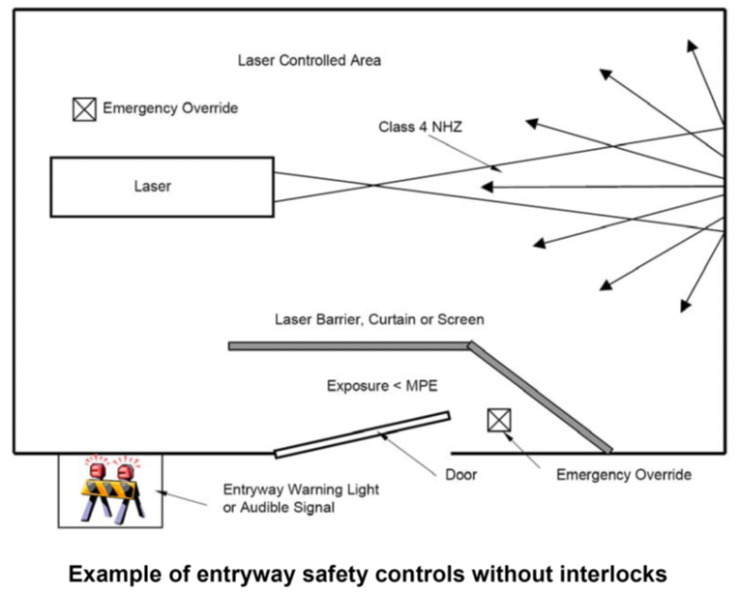

viI. Control MEASURES

<Reference any control measures established to improve laser safety in the laser controlled area. Indicate how to navigate and properly utilise these measures. Ex: Master switches, key locks or keypads, enclosure interlocks, fire-resistant curtains, etc. For Personal Protective Eyewear include the following sample table. If multiple types of Personal Protective Eyewear are available in the lab, include verification procedures for Personnel.>

For this laser…. |  |  | … use this eyewear
Procedure | Laser Type | Wavelength | Wavelength | Optical Density | Manufacturer
Laser Ablation | Nd:YAG | 1070 nm | 855-1085 nm | 5 + | Laser Safety Industries

vIII. TRAINING REQUIREMENTS

<Describe the minimum proficiency requirements that personnel must demonstrate before working with the laser equipment identified in this SOP. Training includes, but is not limited to Health and Safety required training modules and in lab hands-on training>

IX. MAintenance requirements

<Describe the required maintenance for any equipment used in this procedure. Information on maintenance includes, but is not limited to; a description of the maintenance procedure; responsible person; frequency of procedure and documentation required. Make accessible equipment manuals and contact information of regular technician, maintenance person, or manufacturer in case of equipment malfunction. >

X. Operating Procedures
<Present concise steps in point form to follow in order to accomplish the desired task. Avoid copy-pasting steps to keep reader alert and following closely. If necessary, include computer screenshots for navigating software. Recommended steps include, but are not limited to:
- Initial preparation of laboratory environment including gathering of experimental materials, warming up equipment, signing in to schedule, etc.
- Prepare target for lasing through sterilization, turning on ventilation, measuring, etc.
- Equipment start up protocols and specialized procedures such as safety tests, alignments, calibrations, lens focusing, etc.
- Operating conditions used: power, wavelength, pulse duration, Q-switch mode, etc.
- Data collection method and storage practices
- Shut down protocols for equipment
- Lab clean-up procedures after experimentation has finished. >.

xi. Related Documents
<Reference any other internal documents related to this work here. This could include, but is not limited to; other procedures, documentation etc>.
XII. REFERENCES
<Include any reference used to develop your procedure here.>
XIII. OPERATOR REVIEW
<”I have read and reviewed the above guidelines. I understood the presented protocols and procedures and agree to work in accordance with them whenever I use the indicated laser or laser system. “
Name, Date, Signature
__________________
__________________
__________________ .>

LASER SAFETY CONTACTS:
Primary Laser Operator: (Name) (Phone #)
Laser Safety Officer: Tiffany Moore 807-343-8110 ext. 8806
Maintenance/Repair Contact: (Name) (Phone #)
Lakehead Security: 807-343-8110 ext. 8911 (emergency)
Lakehead Security: 807-343-8110 ext. 8569 (non-emergency, keep in touch)

