<Text in blue is provided for informational purposes only and should be deleted when writing your Standard Operating Procedure (SOP). This document is intended as a guideline and should be used as inspiration. A separate SOP is required for each laser in the lab.>

I. PURPOSE

<Describe briefly what this procedure should accomplish>

II. HAZARDS

<Describe all potential consequences of misuse of the equipment in the procedure. Ex: Hazards to eyes, hazards to skin, electrical hazards, etc >

III. LASER DESCRIPION

<Describe the equipment and all details relevant to laser use that are applicable including but not limited to :hazard classification, lasing medium, beam divergence, aperture diameter, pulse length, pulse energy, repetition rate, maximum output power, wavelengths range. The laser or laser system must be identifiable through use of serial number, manufacturer, or model number. >

IV. LASER CONTROLLED AREA

<Indicate the typical laser location (site, building, room number). Add a diagram of the area layout with the beam path indicated; include locations of interlocks, emergency shut-offs, personal protective equipment, and other relevant safety features.>

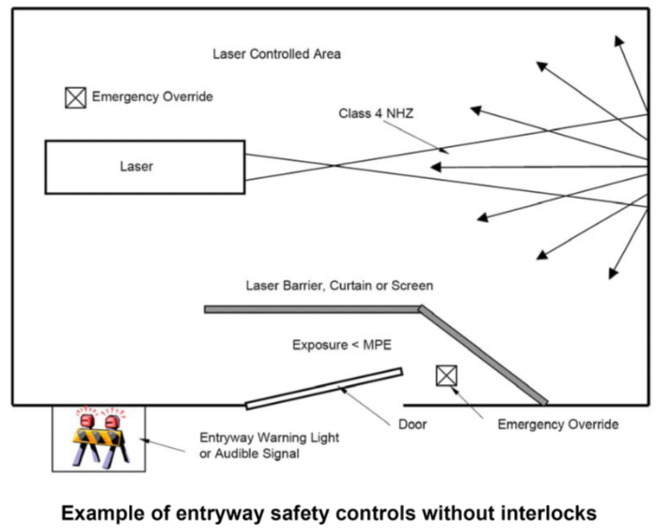

v. Control MEASURES

<Reference any control measures established to improve laser safety in the laser controlled area. Indicate how to navigate and properly utilise these measures. Ex: Master switches, key locks or keypads, enclosure interlocks, fire-resistant curtains, etc. For Personal Protective Eyewear include the following sample table. If multiple types of Personal Protective Eyewear are available in the lab, include verification procedures for Personnel.>

For this laser…. |  |  | … use this eyewear
Procedure | Laser Type | Wavelength | Wavelength | Optical Density | Manufacturer
Laser Ablation | Nd:YAG | 1070 nm | 855-1085 nm | 5 + | Laser Safety Industries

vI. General Advisements

<During laser alignments and calibrations, many laser safety features and protections are removed or disabled. As such, the majority of laser accidents occur during alignments and calibrations. Reinforce the need for security with a list of general advisements. Examples include but are not limited to:

•Only personnel who are immediately involved with the protocol should be in the laser controlled area during calibrations and alignments. Consider working in pairs for additional oversight and vigilance.

•Only trained and authorized personnel should be performing alignments or calibrations. Those who are learning must be accompanied by someone who is trained and authorized.

•Always post an advisory sign outside the working area during an alignment or calibration to alert those outside that normative safety measures have been reduced and a heightened laser hazard is present.

• Do not look directly into the laser beam.

•All alignment and calibration procedures should be performed at the minimum possible power output at which the laser can perform the operation.

•Pulsed lasers should be aligned or calibrated in single pulse mode when possible.

• Wear suitable laser safety eye-wear at all times during alignment and calibration procedures. Wear additional skin protection when necessary.

• Terminate all stray laser beams and be aware of diffuse or specular reflecting surfaces.

• Remove or cover all reflective clothing or jewelry, including watches. Remove any reflective makeup products, being especially conscious of the possibility of releasing loose glitters or shimmer powders into the air.

• Be cautious using sensor cards with glossy surfaces or other reflective tools.

• Ensure beams are not at eye level for either seated or standing individuals. Look away from working area when bending down. Keep beams horizontal or as close to horizontal as possible.

• Encase the beam as much as possible using alternative protections such as tubing, fire resistant curtains, or shields.

•Whoever moves the standard beam path using optical tools like lenses, prisms, or mirrors is responsible for making sure that all stray beams as a result of that alteration are properly terminated, and that all related personnel are made aware of the new beam path if it is not returned to its standard conformation.

•Always use a shutter when putting new optical elements, in the beam path.

• Remove all unnecessary tools from the working area, paying special attention to potential flammables such as chemicals agents, loose papers, or boxes.

• Use beam blocks behind optical components to ensure no stray beams while placing additional components on optical table. >

vii. Tools and Equipment

<Describe and list the tools or equipment to be used during the alignment procedures. Examples include but are not limited to: steering mirrors, sensor cards, irises, shutters, neutral density filters, specialty alignment glasses, Hartman wavefront sensors, manual intensity controllers, laser power meters, pocket cells, beam expanders, beam splitters, prisms, lenses, beam terminators, etc. Provide a few words to explain the function of the tool or equipment in the protocol. >

VIII. Operating Procedures
<Present concise steps in point form to follow in order to accomplish the desired task. Avoid copy-pasting steps to keep reader alert and following closely. If necessary, include computer screenshots for navigating software. Recommended steps include, but are not limited to:
- Initial preparation of laboratory environment including posting alignment warning signs, equipping PPE, gathering of alignment tools and equipment, warming up the laser, signing in to schedule, etc.
- Make a plan for the intended beam path including all optical elements it may traverse through. This includes beam splitters, beam stops, angled mirrors, etc. Make sure that all beams are accounted for and safely terminated.
- Place and prepare tools on optical table for alignment or calibration. Make sure they are well secured and free of dust.
- Remove all safety measures which are required to perform the laser alignment or calibration procedure, including but not limited to automatic shutters, interlocks, protective barriers, etc.
- Equipment start up protocols for alignment mode or calibration mode.
- Operating conditions used: power, wavelength, pulse duration, Q-switch mode, etc.
- Align or calibrate laser in accordance with desired methods. Options include but are not limited to, aligning the beam with an iris shutter, using a laser power meter to track variability in power output, adjusting UV beam based on UV sensor card, etc.
- Shut down protocols for equipment
- Restore all prior safety measures in accordance with instructions set forth by manufacturer’s standards.
- Lab clean-up procedures after protocol has finished. >.

Ix. Related Documents
<Reference any other internal documents related to this work here. This could include, but is not limited to; other procedures, documentation etc>.
X. REFERENCES
<Include any reference used to develop your procedure here.>
XI. OPERATOR REVIEW
<”I have read and reviewed the above guidelines. I understood the presented protocols and procedures and agree to work in accordance with them whenever I use the indicated laser or laser system. “
Name, Date, Signature
__________________
__________________
__________________ .>

LASER SAFETY CONTACTS:
Primary Laser Operator: (Name) (Phone #)
Laser Safety Officer: Tiffany Moore 807-343-8110 ext. 8806
Maintenance/Repair Contact: (Name) (Phone #)
Lakehead Security: 807-343-8110 ext. 8911 (emergency)
Lakehead Security: 807-343-8110 ext. 8569 (non-emergency, keep in touch)

