FIRE SAFETY PLAN FOR:

Centennial Building

Lakehead University

955 Oliver Road

Thunder Bay, Ontario

P7B 5E1

Reviewed without changes - June 2025

Reviewed by:  Brenda Huska  Lakehead University  Health & Safety | Reviewed by:  Kevin Anderson  Division Chief – Fire Prevention, Education & Investigation  Thunder Bay Fire Rescue

Table of Contents
Chapter 1: Introduction 6
Chapter 2: Audit of Human Resources 7
Chapter 3: Audit of Building Resources 8
3.1 General Description 8
i. Occupancy and Use 8
ii. Fire Department Access 8
3.2 Fire Alarm System 9
i. Sequence of Operation 9
ii. Ancillary Functions 9
3.3 Special Extinguishing Systems 10
i. Sequence of Operation 10
ii. Ancillary Functions 10
3.4 Standpipe System 10
3.5 Fire Hydrants 10
3.6 Fire Extinguishers 11
3.7 Elevators 11
3.8 Emergency Power 11
3.9 Main Hydro Shut-Off 11
3.10 Gas Shut-Off Valve 12
3.11 Water Shut-Off 12
3.12 Hazards 12
Chapter 4: Building Schematics 13
4.1 Fire Access Routes 13
4.2 Site Plan 14
4.3 Basement Floor Plan 15
4.4 Main Floor Plan 16
4.5 Second Floor Plan 17
4.6 Third Floor Plan 18
4.7 Fourth Floor Plan 19
4.8 Greenhouse Floor Plan 20
Chapter 5: Responsibilities & Emergency Procedures 21
5.1 Building Owner and Management (President, VP Finance & Administration) 21
5.2 Employers, Managers and Supervisors 22
5.3 Physical Plant (Mechanical & Electrical Staff) 23
i. Emergency Procedures - Physical Plant Staff 23
5.4 Security 24
i. Emergency Procedures- Security Services 24
5.5 Fire Wardens 25
i. Emergency Procedures – Fire Wardens 26
5.6 Teachers and Instructors 27
i. Emergency Procedures – Teachers and Instructors 27
5.7 Evacuation Meeting Locations 28
5.8 Persons Requiring Assistance to Evacuate 28
i. Emergency Procedures- Persons Requiring Assistance to Evacuate 29
5.9 All Occupants 30
i. Emergency Procedures- All Occupants 30
5.10 Extra Precautions While Exiting 31
5.11 Special Evacuation Procedures 31
i. Fire Alarms During Examinations 31
ii. Contractors & Cleaning Staff 31
5.12 Laboratories 32
i. Working Safely 32
ii. Emergency Procedures - Laboratories 34
5.13 Chemistry Stores 35
5.14 Flammable Storage CB 1029 35
5.15 Biology Aquatics Facilities 36
5.16 Hazardous Materials Emergencies 36
i. Minor Chemical Spills 36
ii. Major Chemical Spills 36
5.17 Fire Service Elevator-Operation Instructions 37
i. Phase 1 Operation 37
ii. Phase 2 Operation 37
iii. Return to Phase 1 37
Chapter 6: Fire Extinguishment, Control or Confinement 38
6.1 Suggested Operation of Portable Fire Extinguishers 38
6.2 Classification of Fires 39
6.3 Classification of Fire Extinguishers 39
Chapter 7: Fire Hazards and Fire Prevention 40
7.1 Housekeeping 40
7.2 Fire Doors 40
7.3 General Hazards 40
7.4 Electrical Hazards 40
7.5 Extension Cords 41
7.6 Space Heaters and Appliances 41
7.7 Storage Areas 41
7.8 Flammable and Combustible Liquids 42
7.9 Compressed Gas 42
7.10 Hot Works 43
7.11 Special Events 43
i. Portable Cooking Devices 43
Chapter 8: Fire Protection Measures 43
8.1 Fire Alarms & Pull Stations 43
8.2 Fire Extinguishers 43
8.3 Emergency Exits 43
8.4 Emergency Lighting 44
8.5 Fire Routes 44
Chapter 9: Alternative Measures for Fire Safety 44
9.1 Fire Alarm Systems 44
9.2 Water System Shutdown 44
9.3 Emergency Power Shutdown 45
9.4 Fire Watch 45
9.5 Exits 45
9.6 Fire Extinguishers 45
Chapter 10: Fire Drills 45
Chapter 11: Maintenance Schedule as Required by the Ontario Fire Code 46
11.1 Daily Tasks 46
11.2 Monthly Tasks 47
11.3 Semi-annual Tasks 47
11.4 Annual Tasks 47
11.5 Tasks Every Five (5) Years 48
11.6 Tasks Every Six (6) Years 48
11.7 Tasks Every Twelve (12) Years 49
11.8 Tasks, As Required 49
Appendix A: Fire Drill Report 50

Chapter 1: Introduction

As required by the Ontario Fire Code, Section 2.8, (Ontario Regulation 213/07 of the Ontario Fire Protection and Prevention Act, as amended), this Fire Safety Plan has been prepared by Lakehead University for the Centennial Building, 955 Oliver Road, Thunder Bay, Ontario.
The purpose of the plan is to provide safety information for all occupants in the event of a fire, to ensure the effective use of life saving features in the building, and to prevent fires from being initiated. This fire safety plan has been designed to suit the resources of the Centennial Building. This plan must be approved by Thunder Bay Fire Rescue; however, Lakehead University is responsible for ensuring that the information provided in this fire plan is accurate and complete.
Information found within this Fire Plan includes: contact information, an audit of building resources, maintenance of building resources (as required by the Ontario Fire Code), building schematics, and an outline of responsibilities, emergency procedures, control and extinguishment of a fire, fire protection measure and fire hazards and prevention.
The Fire Protection and Prevention Act, Part VII, Section 28 states that any person who contravenes any provision of the fire code is guilty of an offence. If convicted a company or corporation is liable to a fine of not more than $100,000. Any individual, director or officer of a corporation is liable for a fine of not more than $50,000 or imprisonment for a term of not more than one year, or both.
The Fire Safety Plan shall be reviewed as often as necessary, but at intervals not greater than twelve (12) months, to ensure that it takes account of changes in use and other characteristics of the building. The Chief Fire Official is to be notified regarding any subsequent changes in the contents of the approved Fire Safety Plan.
This official document is to be kept readily available at all times for use by staff and fire officials in the event of an emergency
The approved location of the Fire Safety Plan for the Centennial Building is the Security Office, UC 1016. In addition, copies will be kept in the Health & Safety Office and in a Fire Safety Plan box located by the Fire Alarm Annunciator.
Electronic copies of the Fire Plan will be posted on the Health & Safety website.

Chapter 2: Audit of Human Resources

Building Owner | Lakehead University  955 Oliver Road  Thunder Bay, ON P7B 5E1  Phone: 807-343-8110
President | Dr. Gillian Siddall  955 Oliver Road  Thunder Bay, ON P7B 5E1  Phone: 807-343-8010 ext.8200
Vice President, Finance& Administration | Kathy Pozihun  Phone: 807-343-8010 ext.8383
Director, Physical Plant | Hugh Briggs  Phone: 807-343-8010 ext.8790
Health & Safety, Office of Human Resources | Brenda Huska  Phone: 807-343-8010 ext.8806  Tiffany Moore  Phone: 807-343-8010 ext.8671
Security Staff | On site 24/7, minimum 3 people  Phone: 807-343-8911 (Emergencies)  Phone: 807-343-8010 ext.8569 (Non-emergency)
Maintenance Staff | Physical Plant, available from 8am to 4pm  (After hours contact Security)  Phone: 807-343-8010 ext.8273
Cleaners | Physical Plant, Arno Kalbus, Facilities Manager  Phone: 807-343-8010 ext.8962  Physical Plant, Services Supervisor,  Phone: 807-343-8010 ext.8968
Fire Alarm Monitoring Company | Tbay Tel  Phone number and passwords are held by Security Services (807-343-8010 ext.8569).

Chapter 3: Audit of Building Resources

3.1 General Description
The Centennial Building, located at 955 Oliver Road, is a non-combustible 4-storey building with one basement level constructed in 1967.
The operating hours of the building are 6am to 10pm, Monday to Friday.

Occupancy and Use
Basement- Janitors closets, Mechanical Rooms, Washrooms, Offices, Storage Rooms, Aquatic Animal Facility, Autoclave Room, Workshops, Unit Operations, Hydraulics & Hydrology, Laboratories (Biohazardous, Instrumentation, Environmental, Soils Industrial Waste, Flume, Dry Fluids, Highways, Heat Transfer, Optics).
Main Floor- Janitors closets, Washrooms, Offices, Storage Rooms, Prep Rooms, Computer Labs, Electrical Shop, Hydraulics Pump, Waste Room, Dark Room, Receiving Area, Compressed Gas Storage, Flammable Storage , Laboratories (Biohazardous, Flow, Paper Testing, Petroleum, Meteorology, Materials, Structures, Printed Circuits, Manufacturing, Mechatronics).
Second Floor- Janitors closets, Electrical Room, Mechanical Room, Washrooms, Offices, Storage Rooms, Machine Shop, Prep Rooms, Computer Lab, Laboratories (Teaching, Optics, Electrical/Magnetic, Fluids, Instrumentation), Chemical Stores.
Third Floor- Janitors closets, Washrooms, Offices, Storage Rooms, Prep Rooms, Biology Museum, Hebarium, Lecture Halls, Laboratories (Biohazardous, Teaching, Histology).
Fourth Floor- Janitors closets, Mechanical Rooms, Washrooms, Offices, Storage Rooms, File Room, Lecture Halls, Library, Ham Radio Room, Conference Room.
Outbuildings- Greenhouse.

Fire Department Access
Firefighters will access the property via Oliver Road by either the Lot 5 or the Agora entrance. Security Services will call in detailed instructions to the city’s Emergency Service Dispatch and provide specific information regarding the alarm, including the road and building entrance to use and any details concerning the fire (ie. Which zone is affected, any laboratories, chemical storage, etc.).

3.2 Fire Alarm System
This building is provided with an Edwards IRC3 single stage system.
Main Control Panel location: CB 0011, Electrical Room
Annunciator Panel locations: The annunciator is located in the University Centre (UC) by the Main entrance of the Agora (X1037). The Centennial Building alarm is on the lower section of the panel. A parallel unit is located in the security office, UC 1016.

Sequence of Operation
Upon activation of a fire alarm initiating device in any portion of the Centennial Building or the Greenhouse, a general fire alarm will sound throughout the both buildings.

Ancillary Functions

The fire alarm system is activated by:
- Manual pull stations
- Smoke detectors
- Duct smoke detectors
- Heat detectors
- Supervised flow switch
- Special Extinguishing System

Upon activation of the fire alarm system:
- A fire alarm signal will be transmitted to the Security Office and confirmed at their annunciator panel. A fire alarm signal will also be transmitted to an independent off-site monitoring station.
- The fire alarm annunciator will display information regarding which zone is affected.
- Air handling unit fans will shut-down.
- The Fire Service elevators (X0009R and X0008) will recall.
Fire dampers are present throughout the building, located in the duct work. Dampers operate via thermal melts and are not tied to the fire alarm system.

3.3 Special Extinguishing Systems
The Chemical Storage Room (CB 1029) is equipped with a Notifier AFP 200 single stage CO₂ Suppression System.
The control panel is located in the Centennial Building, room 1024. CO2 tanks are located in room 1027.

Sequence of Operation
The CO₂ Suppression System is tied into the Centennial Building fire alarm system and displayed on the Centennial Building annunciators (Agora entrance and in Security). Upon activation a general fire alarm will sound throughout the Centennial Building and the Greenhouse.

ii. Ancillary Functions

The CO₂ Suppression System is activated by:
- Manual pull stations (5 second delay prior to activation).
- Any two (2) heat detectors (30 second delay prior to activation).

Upon activation of the CO₂ Suppression System:
- After a brief delay, as described above, the CO₂ Suppression System will initiate.
- The fire alarm for the Centennial Building will be activated alerting occupants to evacuate immediately.
- The alarm will be transmitted to Security (UC 1016) and confirmed at their annunciator panel. A fire alarm signal will also be transmitted to an independent off-site monitoring station.
- The fire alarm annunciator in Security will display information regarding which zone is affected.
- Air handling unit fans will shut-down.
- The Fire Service elevators (X0009R and X0008) will recall.

3.4 Standpipe System
The Centennial Building is equipped with a standpipe and hose system. Fire hose cabinets are located throughout the building, as indicated on the floor plans. All fire hose cabinets house portable fire extinguishers. This system also includes supervised tamper switches and a flow switch (CB 0023).
The main shut-off valve for the standpipe system is located in a basement Mechanical room (CB 0023), as shown on the floor plan.
The Fire Department connection is located on the north side of the building, as shown on the site plan.

3.5 Fire Hydrants
Private and municipal hydrants are located as shown on the site plan. The private hydrants are connected to the municipal water supply. Municipal hydrants are located along the perimeter of Oliver Road.

3.6 Fire Extinguishers
Fire extinguishers are located throughout the Centennial Building and in the Greenhouse. See floor plans for locations.

3.7 Elevators
Three elevators serve the building two of which are fire service elevators (X0009R and X0008). Refer to floor plans for locations.
- Upon a general alarm both fire service elevators will capture to the main floor.
- If the smoke detector on the main floor in front of the elevator goes into alarm the elevator will retrieve to the alternate home (Second Floor).
- After recall of the fire service elevators phase two (2) can be activated by Firefighters using the fire service key switch.
The third elevator (X0009L) will operate normally upon activation of the Fire Alarm. All occupants are directed to not use the elevators in the event of a fire alarm. Refer to section 5.17 for more detail.

3.8 Emergency Power
Emergency power is provided by the emergency generator in the powerhouse building (1 megawatt Kohler generator). This emergency generator runs off diesel fuel and will power the main campus for a maximum of 4 days.
Emergency power supplied to the Centennial Building will run the Emergency Lighting, Exit Lights and the Fire Alarm System.
The main fire alarm system and the Notifier AFP-200 panel for the CO2 Suppression system are equipped with battery backup contained within the fire alarm panel. In the event of a power failure, the batteries provide sufficient power to allow the fire alarm to operate in “supervision” mode for 24 hours and the alarm to sound for at least 60 minutes.

3.9 Main Hydro Shut-Off
Two main hydro disconnect switches service the Centennial building. One in CB 0011 supplies electricity for the B-block portion of the Centennial Building (proximal to the University Centre). The second, located in CB 0027, supplies electricity to the A-block of the Centennial Building (proximal to the Greenhouse). Both locations are shown on the basement floor plan.
The Greenhouse main hydro disconnect switch is located in room 1001A of the Greenhouse.

3.10 Gas Shut-Off Valve
The main gas shut off valves are located in the basement of the Centennial Building and in the Powerhouse. In CB 0024 there are 3 gas shut-off valves, as shown on the site plan. One controls the supply of gas to the Centennial Building, another supplies gas to the Greenhouse, and a third supplies gas to the Centennial Building and the Greenhouse.
The gas shut off valve in the Powerhouse controls the natural gas supply to the Centennial Building, Greenhouse, and additional buildings including the University Centre (Cafeteria), Student Centre, Braun Building and CNFER (Forest biology).

3.11 Water Shut-Off
The water main shut off valve and the shut off valve for the standpipe system is located in CB 0023, as shown on the site plan.
Upon request, Maintenance may access outdoor buried curb stops to shut off the buildings water supply.

3.12 Hazards
The following classes of hazardous materials are located in the Centennial Building:
- Compressed Gases
- Flammable and Combustible Materials
  - Flammable and Combustible Solids
  - Flammable and Combustible Liquids
  - Pyrophoric Materials
- Oxidizing Materials
- Poisonous and Infectious Materials
  - Material Causing Immediate and Serious Toxic Effects
  - Material Causing Other Toxic Effects
  - Biohazardous Infectious Material
- Corrosive Materials
- Dangerously Reactive Materials
  - Water Reactive
Upon arrival at the scene, Lakehead University Security Staff can provide the Fire Department personnel with the exact locations of hazardous materials in the building.
Safety Data Sheet hardcopies are accessible in each room that contains hazardous materials.

Chapter 4: Building Schematics 4.1 Fire Access Routes

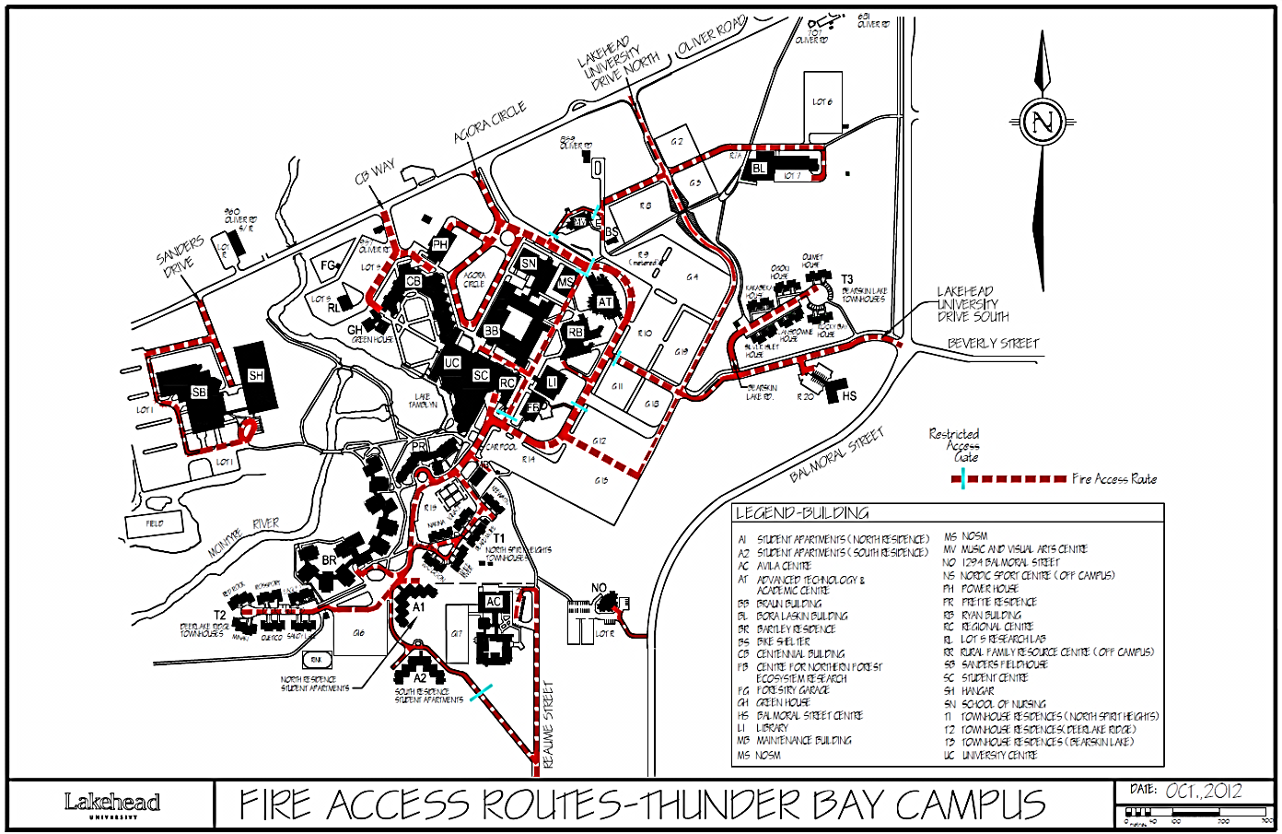

4.2 Site Plan

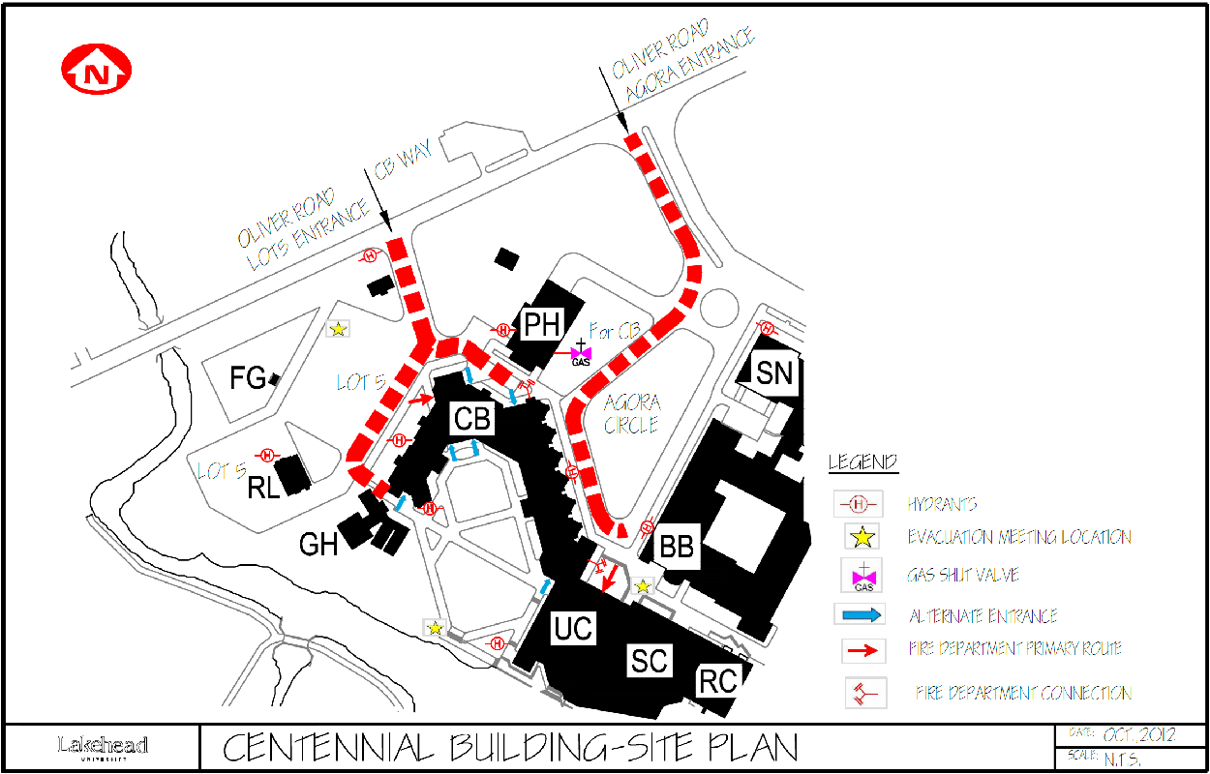

4.3 Basement Floor Plan

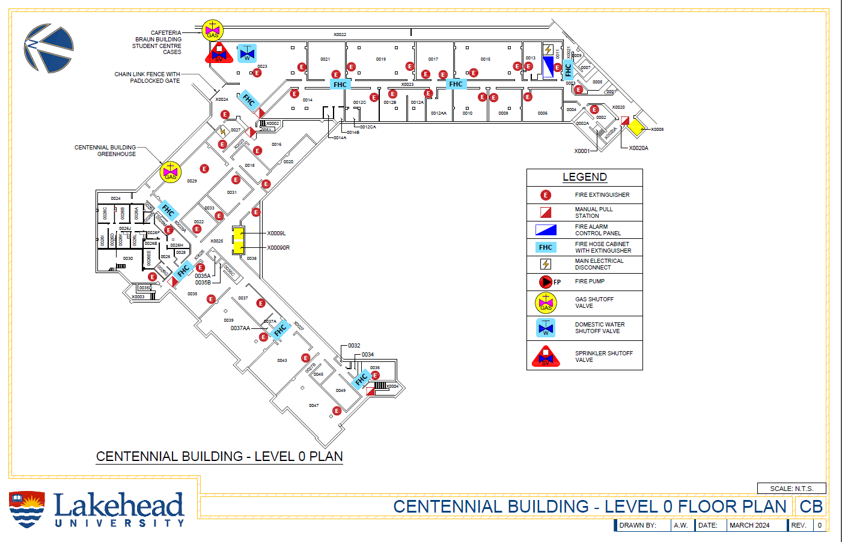

4.4 Main Floor Plan
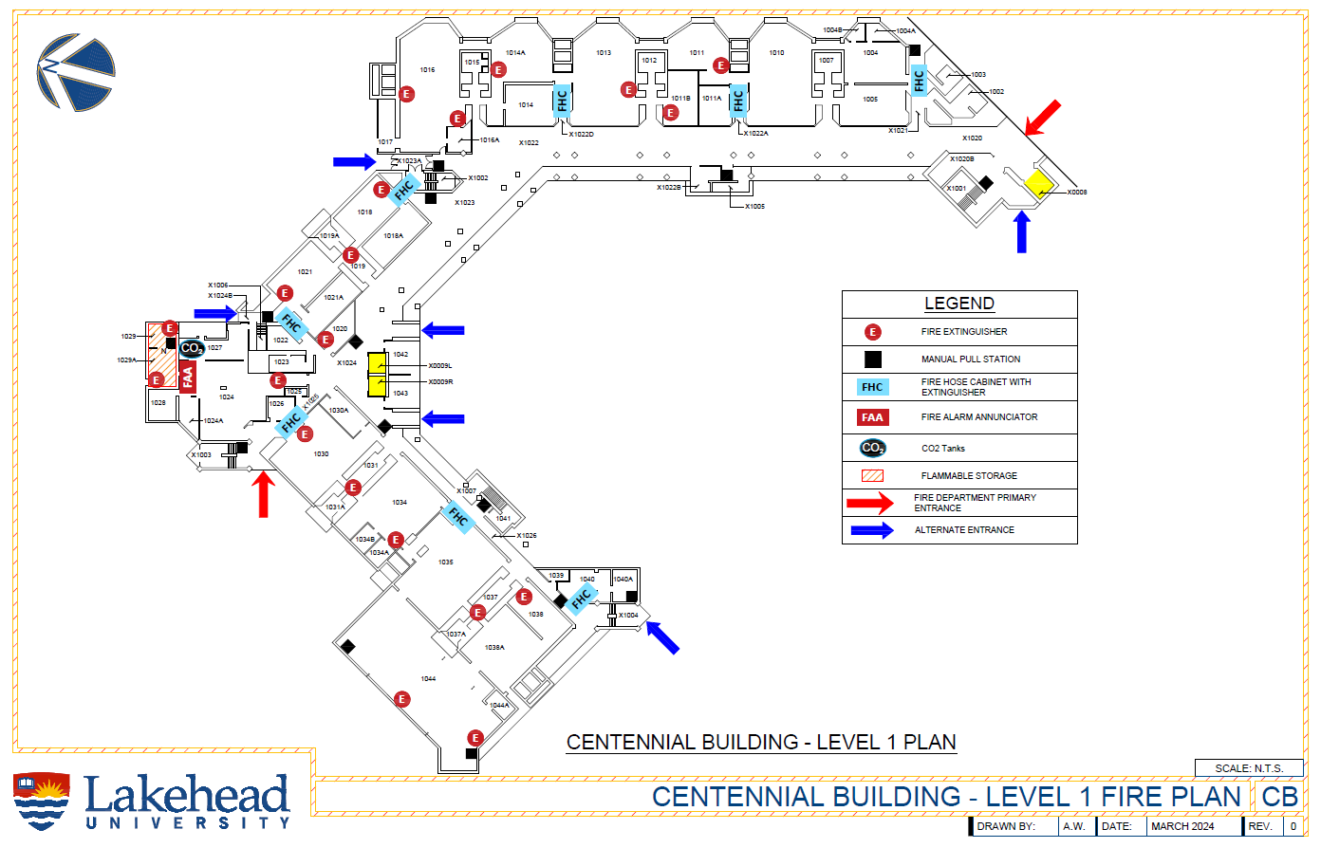

4.5 Second Floor Plan
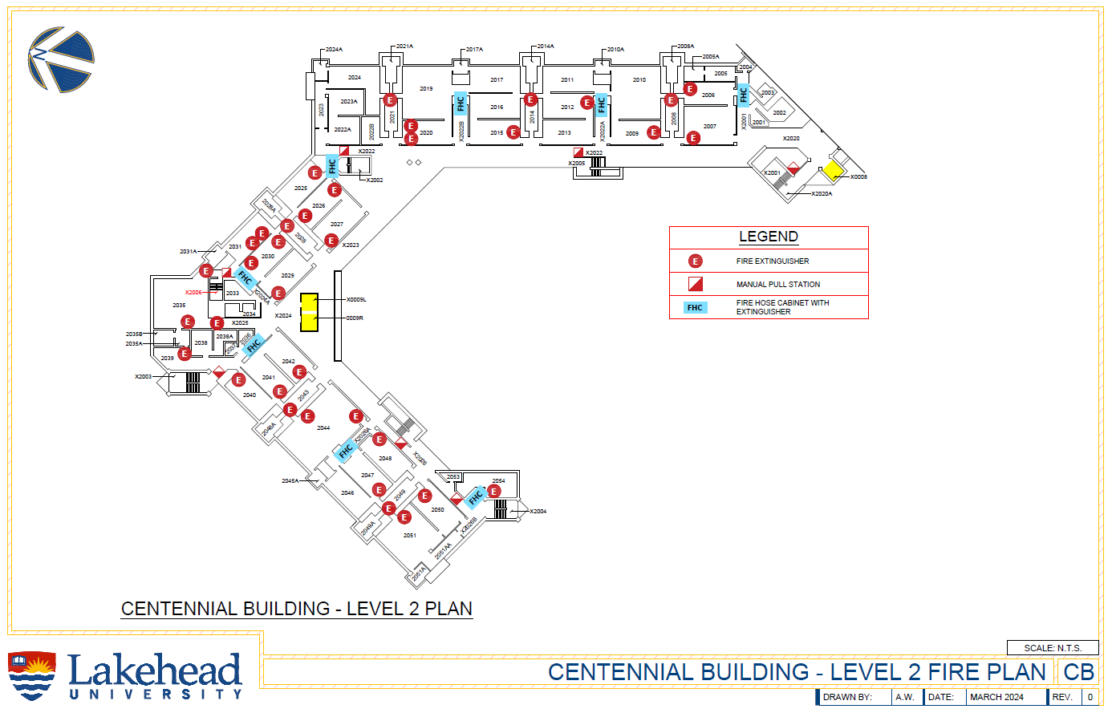

4.6 Third Floor Plan
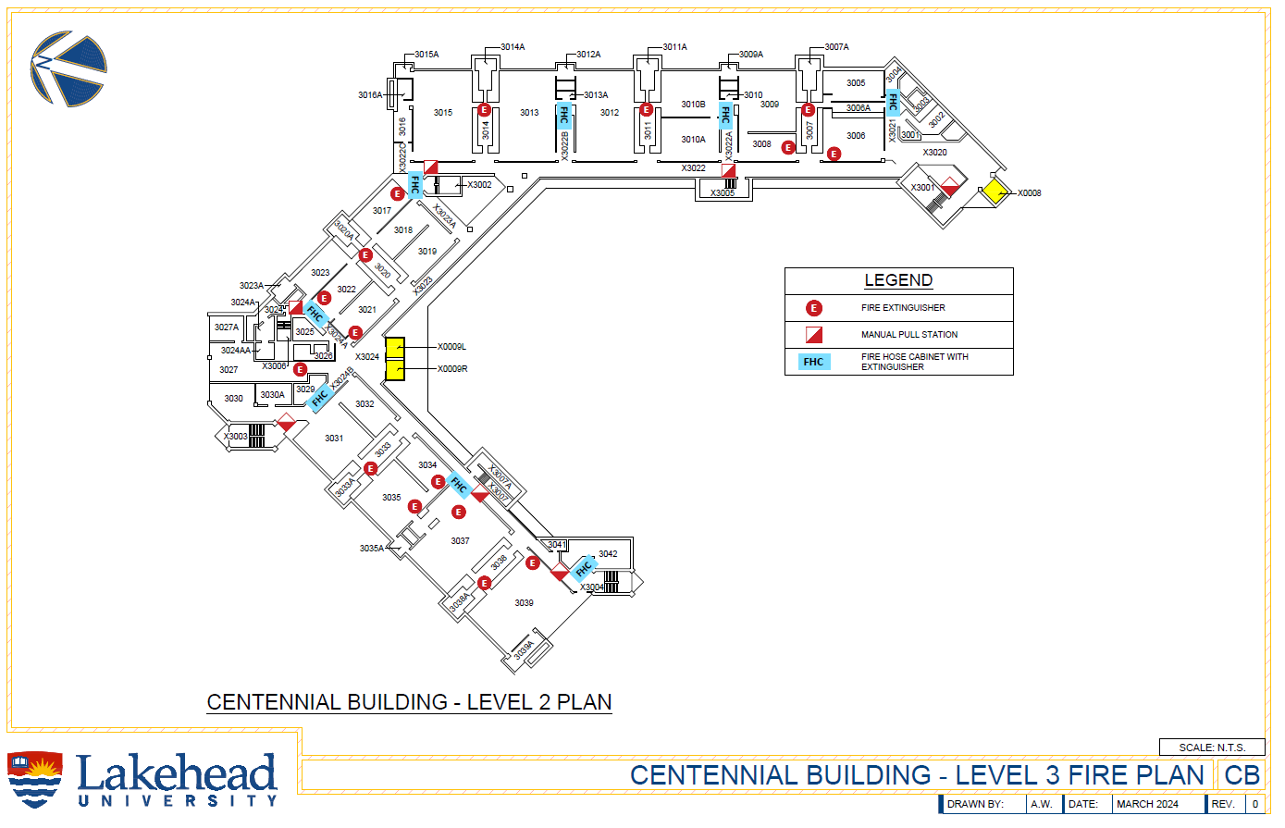

4.7 Fourth Floor Plan
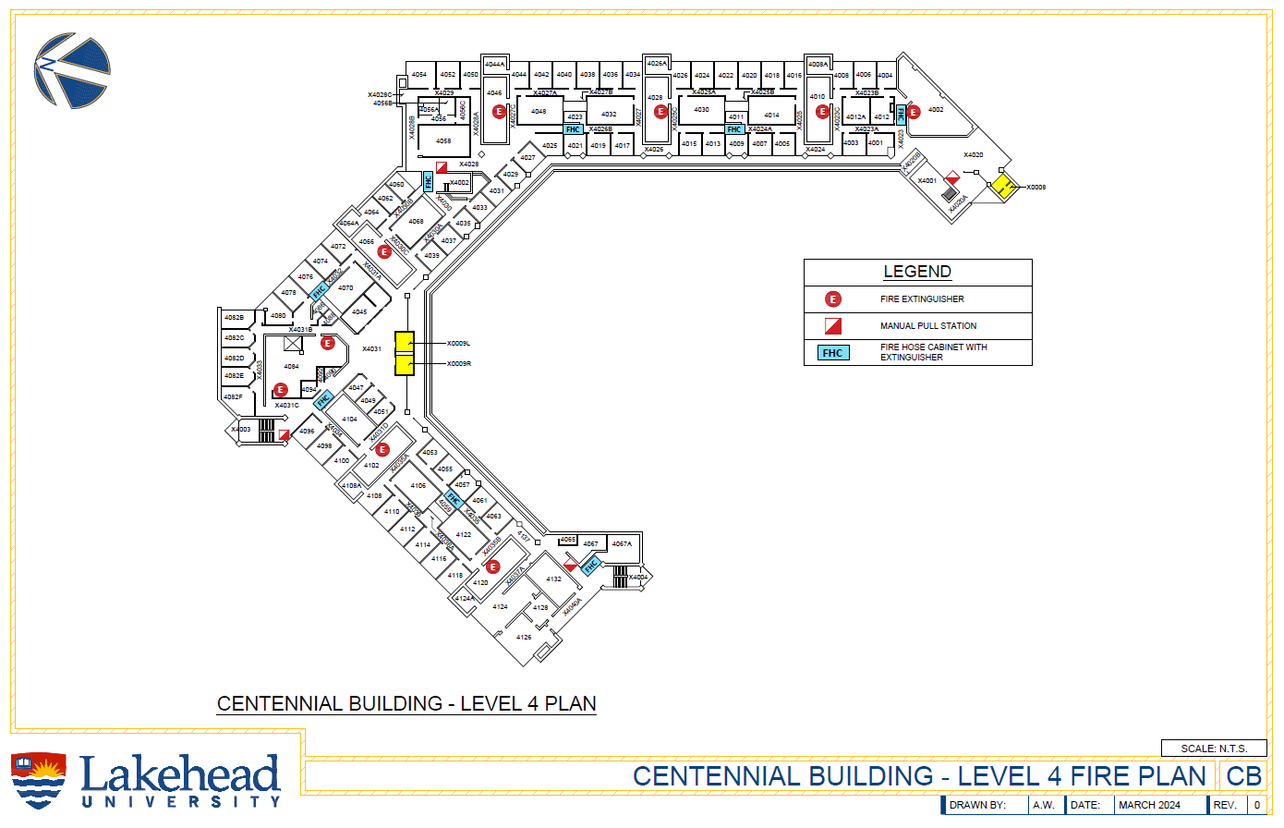

4.8 Greenhouse Floor Plan
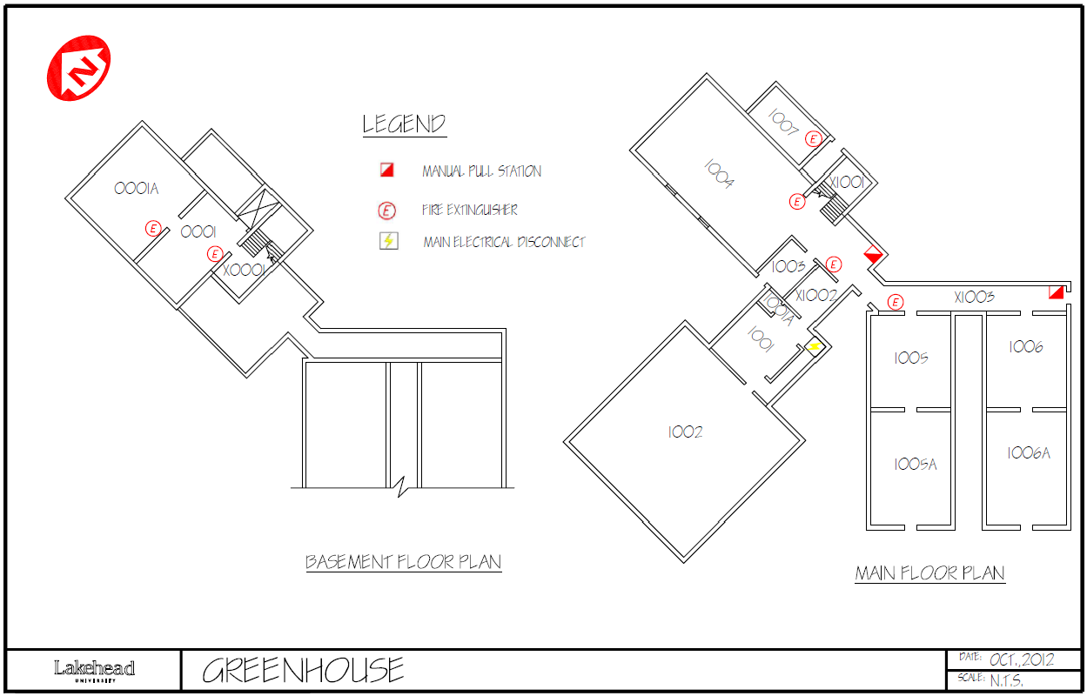

Chapter 5: Responsibilities & Emergency Procedures

The preparation and implementation of a Fire Safety Plan, helps to assure effective use of people and resources to control and eliminate fire hazards in the workplace and to respond effectively to a fire emergency. This will reduce the incidence of fire, protect life safety and reduce the impact of fire should one occur.
The procedures outlined in this Plan will be conducted with all due regard for personal safety
It is not the intent of this Plan to place a person in a hazardous situation that they are not trained or properly equipped for.
Many parties will have a role to play in promoting fire safety in the workplace. Each party will be responsible for certain administrative functions to be performed throughout the year. Some may be responsible for ensuring that tasks are carried out, while others may be responsible for carrying out those tasks.

5.1 Building Owner and Management (President, VP Finance & Administration)
The Ontario Fire Code defines “owner” as “any person, firm, or corporation having control over the property under consideration”. Article 1.2.1.1 of the Ontario Fire Code states, “Unless otherwise specified, the Building owner is responsible for carrying out the provisions of this Code”. Therefore, owners must take responsibility for ensuring compliance with the Ontario Fire Code. The building owner / occupant have numerous responsibilities related to fire safety and must ensure that the following measures are enacted:
- Comply with the Ontario Fire Code.
- Ensure the Fire Safety Plan is developed, approved and fully implemented.
- Keep a copy of the approved Fire Safety Plan on the premises in an approved location.
- Review the Fire Safety Plan annually and revise when changes occur that will affect the information therein, such as contact information or changes to the fire protection system.
- Notification of the Chief Fire Official regarding changes in the Fire Safety Plan.
- Establishment of emergency procedures to be followed at the time of an emergency.
- Post and maintain at least one (1) copy of the fire emergency procedures.
- Appointment and organization of designated supervisory staff (Managers, Maintenance staff, Security or Fire Wardens) to carry out fire safety duties.
- Instruction of supervisory staff and other occupants so that they are aware of their responsibilities for fire safety.
- Designate and train sufficient alternates to replace supervisory staff during any absence
  - “Supervisory staff shall be instructed in the fire emergency procedures as described in the fire safety plan before they are given any responsibility for fire safety”, as outlined in Section 2.8.1.2. (1) of the Ontario Fire Code.
  - It is not necessary that the supervisory staff be in the building on a continuous basis, but they shall be available on the notification of a fire emergency, to fulfill their obligations as described in the Centennial Building Fire Safety Plan.
- Hold drills in accordance with the Ontario Fire Code and in consultation with the Chief Fire Official, incorporating Emergency Procedures appropriate to the Centennial Building.
- Keep adequate records of training and fire drills for a period of at least one-year.
- Ensure that hazards are identified and eliminated or controlled.
- Maintenance of building facilities and ensure that building life safety and fire protection systems provided for occupant safety are maintained.
- Provisions of alternate measures for safety of occupants during shut down of fire protection equipment.
- Assuring that checks, test and inspections as required by the Ontario Fire Code are completed on schedule and that records are retained for a minimum period of two (2) years.

5.2 Employers, Managers and Supervisors
Employers are responsible for fire safety within their area of operation. Employers, Managers and Supervisors must:
- Comply with the Ontario Fire Code within the space you control or lease.
- Ensure that Fire Wardens have been designated and trained to carry out the duties assigned to them under this Plan. Contact Human Resources for a current list of building Fire Wardens.
- Identify key personnel in your department requiring fire extinguisher training. To arrange training contact the Office of Human Resources – Health & Safety (807-343-8010 Ext 8806).
- Review the fire emergency procedures outlined in this Plan with your employees.
- Ensure any person who requires assistance to evacuate the building is identified and that a specific plan is established in the event of an emergency. This plan will be formulated in consultation with the areas fire warden.
- Practice and encourage employees to participate in fire drills conducted in the building.
- Encourage employees to cooperate with Fire Wardens and Security staff as they provide direction during fire alarms and building evacuations.
- Respond to any requests to eliminate fire hazards.
  - Eliminate those departmental fire hazards which you can control.
  - Report any fire hazards that you cannot control to Security, Physical Plant or another Supervisor or department (when another department is involved).

- Laboratory Supervisors shall prepare emergency plans for their work area. Address specific hazards in the facility.
  - Ensure that ALL students and staff who use the laboratory are trained and familiar with these procedures.
  - Proper signage must be displayed on exterior lab doors. Contact the Office of Human Resources – Health & Safety for guidance (807-343-8010 Ext 8806).

5.3 Physical Plant (Mechanical & Electrical Staff)
- Be familiar with the floor area, exits, the locations of any fire safety equipment and the sound of the building’s fire alarm.
- Be familiar with the operation of all fire protection and life safety systems and equipment.
- Provide specific checks, tests, and inspection requirements of the Ontario Fire Code assigned to you, as summarized in Chapter 11 of this Plan.
- Notify the appropriate persons of any planned or unplanned shutdown of fire protection or life safety equipment.
- Assist in implementing alternate measures for fire safety to compensate for the inactive system, as outlined in the Chapter 9 of this Plan.
- Restore the fire protection and fire alarm systems to normal operation after repairs or maintenance are completed or as soon as you are authorized to do so after an emergency.
- Assist in fire prevention by controlling fire hazards and conditions of possible safety threats.
- Promptly address and correct any fire hazards reported to you.
- Physical Plant will be notified by Security of any fire drills taking place.

Emergency Procedures - Physical Plant Staff
Upon notification by Security Services that a fire alarm has been activated, Physical Plant staff will stand by for further instructions.
Electrical Staff will:
- Be notified of all fire alarms and attend the site of any actual fire emergencies, or if the fire alarm system cannot be reset by Security Services.
- Prepare to disconnect the electrical service to the affected area. Disconnection will be at the direction of the Fire Department.
- Request assistance of other Physical Plant Departments as needed.

5.4 Security
- Be familiar with the floor area, exits, the locations of any fire safety equipment and the sound of the building’s fire alarm.
- Participate in fire drills as described in this Plan.
- Assist in fire prevention by controlling fire hazards and conditions of possible safety threats.
- Promptly report or correct any fire hazards you have been informed of.
- Provide specific checks, tests, and inspection requirements of the Ontario Fire Code assigned to you, as summarized in the Chapter 11 of this Plan.
- Notify the appropriate persons of any planned or unplanned shutdown of fire protection or life safety equipment.
- Assist in implementing alternate measures for fire safety to compensate for the inactive system, as outlined in Chapter 9 of this Plan.
- Be familiar with the procedures and operation of the Fire Alarm and Security Systems.
- Be familiar with your role upon notification of a fire alarm.
- Know where the Fire Plan is kept and how to access the buildings material safety data sheets.
- Security must have quick access to fire safety equipment (Fire Alarm Panel, generator room, pull station keys, elevator keys, and service/fire access roads).
- Be available to assist the Fire Department.
As with any emergency Fire Alarms will take priority over any other university business

Emergency Procedures- Security Services

Upon receiving notification of a fire alarm at the security office, you will:
- Check the fire panel and print out for the exact location of the alarm.
- Over the radio, notify the security personnel and dispatch all patrol officers to the appropriate building.
- Call the monitoring company and verify they have received the alarm signal and have contacted the fire department.
- Open electronic access gates if present on the buildings Fire Access Route.
- Await further instructions from the Security Officers on the scene. Upon receipt of a report from the Security Officer on scene, the Security will:
  - Contact Fire Dispatch (807-684-1525) to provide specific information regarding the alarm.
  - Contact Physical Plant and Electrical staff (807-343-8010 Ext 8273) if there is a known fire.
- Alert Human Resources at 807-343-8010 Ext 8806 or 807-343-8010 Ext 8671 or after hours using the Emergency Contact phone numbers filed with Security.
- DO NOT touch the fire panel.
- Any information received on the cause of the alarm will be relayed immediately to the Security Officers on scene.
- Ensure the Fire alarm system is not silenced or reset until authorization is given by the Fire Department.

Upon notification of a fire alarm, Security Officers assigned to patrol will:
- ONE officer will meet the Fire Department at the designated entrance.
  - Advise the Fire Department of any information regarding the cause of the alarm or details of the fire and relay any concerns regarding the zone affected (ie. Laboratories, chemical storage or animal facilities).
- ALL OTHER officers will immediately report to the area in distress and report to the other security personnel the condition of the site.
  - One officer will check the zone indicated by the annunciation panel as being in distress, if it is safe to do so. Report findings to the security office and indicate if there is a need for other services to be called (ie. Ambulance, Electrical, Mechanical). The officer will also report if there is an actual fire, smoke present or if the cause of the fire is known.
  - Ensure fire access routes are unobstructed (Remove any bollards and open gates).
  - One officer will control crowds and ensure that all persons are kept away from the building and the roadway is clear for the Fire Department. Ensure no one re-enters the building until the Fire Department has given the all clear.
- Security officers will follow the instructions of the Fire Department personnel.
- Once authorized by the Fire Department, Security Officers will silence the alarms, reset the activated device, return elevators to normal service, reset maglocks (if applicable) and provide the “All Clear” announcement to those who have evacuated the building.
- Security will facilitate the Fire Department’s investigation (if a fire occurred).
- An incident report must be generated for ALL fire alarms, without exception.
- Forward a copy of the report to the Office of Human Resources – Health & Safety.
Security Officers shall refer to a more detailed description of these procedures in the “Security Services Department Policy & Procedure Manual”.

5.5 Fire Wardens
As with all major buildings on campus the Centennial Building has designated Fire Wardens. Fire Wardens are individuals who volunteer or who are assigned to perform certain functions during fire emergency situations. Wardens can be identified during fire evacuations by their reflective vests
Fire Wardens will direct the evacuation of specific areas (zones) of their building during an emergency and assist with building security. Fire Wardens should be familiar with all potential exit routes, the fire protection measures and emergency procedures in the zone they are responsible for. Wardens will assist in identifying personnel in their zone who may require assistance to evacuate, and ensure that plans are in place to ensure their safety.
Keep the reflective vest in an easily accessible location and ensure that an alternate Warden is informed of your absence. Health & Safety will arrange for training, organize and determine the number of Fire Wardens required for each zone. Contact Lakehead University Office of Human Resources – Health & Safety (807-343-8010 Ext 8806) for a current list of building Fire Wardens.
Fire Wardens will execute their duties with all due regard for their own personal safety

Emergency Procedures – Fire Wardens

On notification of a Fire Emergency, Fire Wardens will:
- Identify yourself as a Fire Warden. Wear your vest.
- Evacuate the area nearest the fire first, if known. Direct people to the nearest exit. If the exit is impassable, direct people to an alternate route.
- Make a sweep of your assigned zone, checking all open rooms, including washrooms and storage rooms, to ensure everyone has left.
- Close any open windows.
- Close, but do not lock, doors in your zone
- Note the name and/or location of any individuals who remain in the building to report to the Fire Department or Security Services staff.
- Ensure persons who require assistance to evacuate or those who cannot evacuate are assisted down the exit stairs or to the nearest exit stair landing. See section 5.8 for more detail.
- Once the zone has been evacuated, leave the building using the closest exit stair.
- Once outside the building, direct evacuees to the designated meeting location (In front of the Agora, Walking path along Lake Tamblyn, or Parking Lot 5, by Oliver Road) or in cases of inclement weather, to an adjacent building and ensure Security Services is notified of your alternate location. Refer to the site plan, Section 4.2, for more detail.
- Immediately notify the Fire Department personnel or Security Services staff of the location and/or name of any individuals who remained in the building and disclose any other information regarding the location or nature of the fire.
- If Fire Department personnel are not on the scene, confirm with Security Services that the Fire Department has been notified.
- Assist the Fire Department personnel and Security Services staff, as requested.
- Stay at the front of your group and keep people well back from the building. Stay visible and do not mingle with the crowd.
- Obtain information from evacuees in your area. If anyone has information for the Fire Department or Security Services staff, ensure that it is reported.
- The end of the Fire Alarm signal DOES NOT indicate that it is safe to re-enter the building. Ensure that no one re-enters the building until the all clear signal has been given by Security Services staff or Fire Department personnel.
- After the fire emergency or fire drill is over, report any problems encountered during the evacuation to the Office of Human Resources- Health & Safety at 807-343-8010 Ext 8806.

5.6 Teachers and Instructors
Teachers and Instructors should act as Fire Wardens for their lecture halls or labs.
To prepare for a fire emergency, be familiar with the floor area, location of exits and evacuations routes. Make note of any persons in your lecture hall or lab who may require assistance to evacuate and be familiar with proper procedures for turning off equipment.
Ensure that any fire hazards in your lecture hall or lab are identified, controlled, or reported to your Supervisor, Physical Plant (807-343-8010 Ext 8273) or Health & Safety (807-343-8010 Ext 8806). Ensure that you and your students participate in fire drills and follow the directions of Fire Wardens, Security Services and the Fire Department.

Emergency Procedures – Teachers and Instructors
- Upon notification of a fire, instruct all students to calmly evacuate the building and announce the location of the nearest exit stair.
- All equipment that cannot be left safely unattended should be turned off.
- Close any open windows.
- Conduct a systematic check of your immediate area for anyone who has not evacuated and look for fire or smoke.
- Follow the last student from the room shutting all doors behind you. Do not lock.
- Ensure persons who require assistance to evacuate or those who cannot evacuate are assisted down the exit stairs or to the nearest exit stair landing. See section 5.8 for more detail.
- Leave the building using the closest exit stair, closing doors behind you. Do not use elevator.
- Follow instructions provided by Fire Wardens, Security Services and the Fire Department.
- Report to Security Services or the Fire Department if you know of anyone still in the building, or if you saw smoke or fire.
- Move away from the building and congregate at the designated meeting location (In front of the Agora, Walking path along Lake Tamblyn, or Parking Lot 5, by Oliver Road) or in cases of inclement weather, to an adjacent building and ensure Security Services is notified of your alternate location. Refer to the site plan, Section 4.2, for more detail.
- Obtain information from evacuees in your area. If anyone has information for the Fire Department or Security, ensure that it is reported.
- Do not return to the building until authorized to do so by the Fire Department, Security or a Fire Warden.

5.7 Evacuation Meeting Locations
There are three (3) designated evacuation meeting locations for the Centennial Building:
- In front of the Agora
- Walking path along Lake Tamblyn
- Parking Lot 5, by Oliver Road
All persons evacuating the Centennial Building must immediately report to the designated location and report to their zones Fire Warden or their Instructor.
During inclement weather Fire Wardens may choose to move the meeting location to an adjacent building. Wardens must ensure Security Services is notified of this alternate location.

5.8 Persons Requiring Assistance to Evacuate
Persons requiring assistance to evacuate are encouraged to identify themselves to their Supervisor or to their Instructors upon commencing employment or classes at Lakehead University. It is the responsibility of Lakehead University to ensure that persons requiring assistance to evacuate are provided with means to leave the premises safely. Faculty and Administration should be aware if there are individuals in their classes or department who require assistance in the event of a fire emergency.
Any special arrangements made for persons requiring assistance to evacuate should be reviewed in advance with the Supervisor or Instructor and the Fire Warden responsible for the zone(s).
For those persons who are unable to evacuate, Fire Wardens, Instructors and Supervisors must know:
- Where a person can be safely left in the eventuality that evacuation from the building is not possible.
- The procedure for reporting the location of persons left in the building to the Fire Department or Security Services.
Immediately inside the exit stair is the best location to await rescue, in the event that evacuation is not possible. Exit stairs are enclosed fire protected stairwells with fire resistant walls and doors designed to protect from smoke and fire. Be familiar with the evacuation plan.

Emergency Procedures- Persons Requiring Assistance to Evacuate
On notification of a Fire, a Supervisor, Instructor or Fire Warden who is aware that a person with requiring assistance to evacuate is present in their workplace or classroom will:
- Ensure that the individual has been notified.
- Carry out your regular duties: instruct all occupants to evacuate via the nearest exit, conduct a systematic check of the immediate area and turn off all equipment if safe to do so.
- If the individual requiring assistance to evacuate has not made alternate plans for evacuation , the following procedure will be followed:
  - The Supervisor, Instructor or Fire Warden will help any person requiring assistance in reaching a safe location outside the building using an exit stairwell, insofar as they are able to do so.
    - Persons requiring assistance should be moved into the exit stair when there is a break in the flow of persons evacuating, or when the stair is clear.
    - If the person is unable to continue while descending, stop at the next door encountered on the way down. Do not obstruct others who are evacuating.
    - Station the person immediately inside the stairwell, if safe to do so, call Security (807-343-8911, extension 8911 or a blue emergency telephone) or exit the building and immediately inform Security Services or the Fire Department of the person’s location.
  - To assist individuals who are unable to evacuate using the stairs, the Supervisor, Instructor or Fire Warden will ensure the person requiring assistance is moved to the nearest exit stairwell landing.
    - Persons who cannot use the stairs are to remain inside the exit stairs, ensuring that the exit stair door remains closed.
    - Any person who wishes to stay with the individual may do so.
    - Contact Security (807-343-8911, extension 8911 or a blue emergency telephone). If a phone is not available exit the building and immediately inform Security Services or the Fire Department of the person’s location.

Those who have begun providing support must ensure the person requiring assistance has been safely evacuated before resuming their regular duties

5.9 All Occupants
All occupants must be familiar with Lakehead University Emergency Procedures to be followed upon discovery of smoke or fire and upon hearing the fire alarm. Occupants will also participate in all fire drills and other fire safety training prescribed by Lakehead University.
Notify your Supervisor, Fire Warden or Instructor if you have a condition that you feel may inhibit your ability to evacuate the building safety without assistance. If you are assigned to assist someone to evacuate, ensure that you know the procedures to be carried out. Make note and report any fire hazards or unsafe conditions observed in the building. Refer to Chapter 7 for more details.

Emergency Procedures- All Occupants

Upon Discovery of Fire or Smoke
- Leave the fire area immediately. Remove any person in immediate danger. Ensure that all doors to the affected area are closed to confine the fire. Do not lock.
- Warn people in the area to evacuate.
- Activate the fire alarm using the nearest pull station.
- Leave the building using the closest exit stair, closing doors and open windows behind you. Do not use the elevator.
- Once at a safe location call 807-343-8911, extension 8911 from a campus phone or use the blue emergency telephone.
- Follow instructions provided by Fire Wardens, Security staff and the Fire Department.
- Report to Security staff or the Fire Department if you know of anyone still in the building.
- Move away from the building and congregate in the designated meeting location (In front of the Agora, Walking path along Lake Tamblyn, or Parking Lot 5, by Oliver Road). Refer to the site plan, Section 4.2, for more detail.
- Do not return to the building until authorized to do so by the Fire Department, Security, or a Fire Warden.

On Notification of a Fire
- Evacuate the building immediately using the nearest exit stair.
- Leave the building using the closest exit stair, closing doors and open windows behind you. Do not use the elevator.
- Follow instructions provided by Fire Wardens, Security staff and the Fire Department.
- Report to Security staff or the Fire Department if you know of anyone still in the building, or if you saw smoke or fire.
- Move away from the building and congregate in the designated meeting location (In front of the Agora, Walking path along Lake Tamblyn, or Parking Lot 5, by Oliver Road). Refer to the site plan, Section, 4.2 for more detail.
- Do not return to the building until authorized to do so by the Fire Department, Security or a Fire Warden.

5.10 Extra Precautions While Exiting
- Check all doors before opening them using the back of your hand.
  - If the door is hot, do not open it. Use an alternate path to exit.
  - If the door is not hot, brace yourself against it and open it slightly, standing to one side. If you detect fire or smoke, feel air pressure or a hot draft, close the door quickly, leaving it unlocked. Use an alternate path to exit.

- If an exit route is not available or you are trapped:
  - Return to a “safe room” (ie. an office) and close the door, leaving it unlocked.
  - Seal off all openings which may admit smoke.
  - Crouch low to the floor if smoke enters the room.
  - Call Security at 807-343-8911 or extension 8911 and alert them to your location. Wait to be rescued.
  - If a phone is not available get the attention of emergency personnel by any means available to you (shout, wave from a window, etc.).
  - Listen for instructions given by authorized personnel.

- If you encounter smoke while exiting and an alternate exit or a “safe room” is not available, drop to your knees and crawl towards the closest exit stair.

5.11 Special Evacuation Procedures

Fire Alarms During Examinations
- Turn your examination over.
- Evacuate the building using the nearest exit stair. Do not use the elevator.
- Follow the directions of your Instructor, Fire Wardens, Security staff and the Fire Department.
- Move away from the building and congregate in the designated meeting location (In front of the Agora, Walking path along Lake Tamblyn, or Parking Lot 5, by Oliver Road).
- Do not return to the building until authorized to do so by the Fire Department, Security or a Fire Warden.

Contractors & Cleaning Staff
- As long as it is safe to do so, turn off any equipment you are using and ensure that it is not left in such a way as to block exits.
- Evacuate the building using the nearest exit stair. Do not use the elevator.
- Follow the directions of Fire Wardens, Security staff and the Fire Department.
- Ensure that the building staff are aware that you have evacuated
- Move away from the building and congregate in the designated meeting location (In front of the Agora, Walking path along Lake Tamblyn, or Parking Lot 5, by Oliver Road
- Do not return to the building until authorized to do so by the Fire Department, Security or a Fire Warden.

5.12 Laboratories
Laboratory facilities will remain locked when unsupervised. Access will be restricted to authorized personnel only. Prior to being granted access, authorized personnel receive training appropriate to the hazards present in the laboratory and will be familiar with emergency response protocols.
Students and Staff must review safe use of chemicals and fire safety plans with their Supervisor prior to starting work in the lab and as often as necessary to ensure familiarity with safe working practices

Working Safely

Storage Areas- Flammables
- All personnel working in laboratories must be trained in the safe handling of flammable and combustible liquids.
- Those working with hazardous chemicals are required to be familiar with the use and handling of chemicals as outlined in the applicable Safety Data Sheets (SDS).
- All flammable liquids are kept in an Ontario Fire Code OReg 213/07 approved flammable cabinet, except for quantities required in one day’s work.
- All flammable cabinets must conform to ULC-C1275, ULI 1275, be FM approved, or meet NFPA 30 standard.
- Quantities of flammable and combustible liquids greater than 300L must be stored in a designated and approved chemical storage room.
- Ensure that flammable materials are stored in approved containers or cabinets and their lids tightly closed.
- As outlined in the Ontario Fire Code, approved containers are those built in conformance with the Transportation of Dangerous Goods Regulations or ULC/ORD-C30, Safety containers.
- Do not use open flame to heat a flammable liquid or to carry out a distillation under reduced pressure.
- If an open flame is necessary, ensure there are no flammable substances or vapours present in the immediate area. Extinguish the open flame when it is no longer needed and NEVER leave an open flame unattended.
- When volatile flammable materials are present, use only non-sparking equipment.
- Discard flammable or combustible waste into approved waste containers only.
- Restrict the quantity of flammable liquids stored in approved glass or metal containers to 5 litres, as per the Ontario Fire Code.
- Storage areas must be kept clean, organized and free of debris.
- For more detail see Section 7.8

Safety storage of compatible chemicals
- Chemicals are stored by reactive class and incompatible chemicals are physically separated from each other.
- Flammable and combustible liquids will not be stored with corrosives, oxidizers, reactive chemicals, or compressed gases.
- Acids are separated from caustics and from reactive metals such as sodium, magnesium and potassium.
- Oxidizers are stored away from organic acids, flammable, combustible and reducing agents (e.g. zinc, alkaline metals) and should not be stored on combustible surfaces.
- Water reactive chemicals are stored in a cool, dry place. In case of fire, a Class D fire extinguisher is used.
- Hazardous chemicals shall not be stored in areas used for ordinary combustible materials (ie. Paper or cardboard boxes) or exposed to direct sunlight or localized heat.
- Safety Data Sheets (SDS) for each chemical must be consulted for proper storage instructions and should be accessible to the storage area.
Refer to SDS for specific incompatibilities
For more detailed information refer to Lakehead University’s “Chemical Storage Procedure” found on the Health & Safety website. http://hr.lakeheadu.ca/wp/?pg=140

Electrical Safety
- Electrical wiring that is defective, frayed or cracked must be replaced. Discontinue use and contact physical plant (807-343-8010 Ext 8273) immediately upon discovery of damaged electrical wiring.
- Extension cords must be unplugged after use and cannot be used as permanent wiring.
- Power bars are acceptable for long term use, provided they are used safely.
- In order to control risk of fire and/or electrocution all lab equipment must be CSA or ULC approved for safe use Ontario.
- Safe use of power bars and accepted certification marks can be review on Lakehead University’s Health & Safety website. http://hr.lakeheadu.ca/wp/?pg=140

Safe use of pyrophoric chemicals
- Pyrophoric materials can ignite spontaneously when exposed to air. Failure to follow proper handling procedures may cause a fire or explosion.
- BEFORE working with pyrophoric reagents, read the relevant Safety Data Sheets (SDS) and understand the hazards. The SDS must be reviewed before using any unfamiliar chemicals and periodically as a reminder.
- Users of reactive materials must be trained in proper lab technique by or under the supervision of their Supervisor and be able to demonstrate proficiency.
- Keep the amount of pyrophoric material present in the lab to a minimum and experiments should be planned so this work is not conducted after hours.
No one should work alone with pyrophoric materials
- A Class ABC dry chemical fire extinguisher must be available within 10 seconds travel time from where pyrophoric chemicals are used. An ABC extinguisher will generally put out the fire but pyrophoric materials may reignite.
- Know the location of the nearest Class D fire extinguisher.
- A container of powdered lime (calcium oxide, CaO) or dry sand should be kept within arm’s length when working with a pyrophoric material. This will be used to completely smother and cover any small spills that may occur.
- Containers carrying pyrophoric materials must be clearly labelled with the correct chemical name and hazard warning.
- Ensure appropriate storage conditions, under an inert atmosphere or under kerosene as appropriate.
- Avoid areas with heat/flames, oxidizers and water sources.
Follow proper cleaning and disposal procedures
- Any container with a residue of reactive materials should never be left open to the atmosphere.
- When used with pyrophorics, inspect all equipment and materials for contamination prior to disposal.
- Empty syringes should be rinsed three (3) times with an unreactive solvent (ie. Hexanes or Toluene), this solvent must be hydrolyzed or neutralized. The empty syringe must then be rinsed three (3) times with an alcohol (ie isopropanol) or acetone, prior to being rinsed with water.
- Any unused or unwanted reactive materials must be destroyed by transferring the material to an appropriate reaction flask for hydrolysis and or neutralization with adequate cooling.
- Supervisors must provide specific written procedures for cleaning of contaminated equipment and destroying unwanted reactive material.
- Contact the Office of Human Resources – Health & Safety to arrange for disposal of hazardous waste (807-343-8010 Ext 8806 or extension 8806).

Emergency Procedures - Laboratories
For laboratories it is important to develop emergency shutdown procedures for processes which may create hazards when unattended. For example,
If safe to do so:
- Turn off equipment that cannot be safely left unattended
- Turn off any natural gas taps in use
- Close the sash of the fume hood
- Cover and/or secure open containers of flammable chemicals or biohazardous agents.
- Remove personal protective equipment prior to evacuating.
Supervisors must develop emergency procedures to address any specific hazards in their laboratories and ensure staff and/or students are trained and familiar with these procedures. Below are basic laboratory fire emergency procedures which Supervisors should adapt.
- As long as it is safe to do so:
  - Turn off any equipment that cannot be safety left unattended.
  - Turn off any open natural gas taps and secure hazardous materials in use.
  - Shut any open windows or doors.
- Remove your personal protective equipment prior to exiting.
- Instruct any persons you encounter to evacuate the building using the nearest exit stair. Do not use elevators.
- Follow the directions of your Supervisor, Fire Wardens, Security staff and the Fire Department.
- Report to Security or the Fire Department if you know of anyone still in the building or have any details regarding the fire.
- Move away from the building and congregate in the designated meeting. Refer to the site plan, Section 4.2, for more detail.
- Do not return to the building until authorized to do so by the Fire Department, Security or a Fire Warden.
In the case of fire or explosion, immediately turn off burners and other heating devices and stop reactions in process, if it is safe to do so. Activate the fire alarm, call 807-343-8911 (extension 8911) from a safe distance and follow the emergency procedures outlined in the emergency procedures flip book.

5.13 Chemistry Stores
Chemistry stores, houses a large variety and quantity of chemicals: Acids, Bases, Oxidizers, Flammable Solvents, Combustible metals, etc. Every attempt is made to keep incompatible materials separated and away from the means of egress.
Upon the notification of a fire, all staff and students must evacuate and the doors to chemistry stores must be closed.
Upon discovery of a fire there is one CO₂ fire extinguisher, two ABC fire extinguishers and one Class “D” (combustible metals) fire extinguisher available. Only trained individuals may attempt to extinguish small fires and only after the fire alarm has been activated and security has been notified (807-343-8911 or extension 8911). If the small fire cannot be easily extinguished or if the fire spreads, evacuate immediately closing doors behind you. Instruct anyone you encounter to evacuate the building as well.

5.14 Flammable Storage CB 1029
The flammable storage room is located away from public areas and is equipped with a CO₂ fire suppression system. Only authorized individuals who have been appropriately trained and will have access to this room. In the event of a small fire there are two ABC extinguishers available for use. Only trained individuals may attempt to extinguish small fires and only after the fire alarm has been activated and security has been notified (807-343-8911 or extension 8911). If the small fire cannot be easily extinguished or if the fire spreads, evacuate immediately closing doors behind you.

The CO₂ suppression system is initiated by the manual pull station in CB 1029 or via activation of the heat detectors. Initiation of the Fire alarm in CB 1029 will in turn activate the Fire alarm system in the Centennial Building.

Once the CO₂ system has been activated it is imperative to evacuate immediately. Exposure to CO₂ gas can be potentially dangerous. Upon exit, close the door behind you, move away from the building and contact Security with details concerning the fire.

Ensure a safe distance is maintained from blow out doors located on the east face of the storage room.

5.15 Biology Aquatics Facilities
CB 0026, CB 0020 and CB 0018 is home to the Biology Aquatics Facility. No special fire procedures are required for this space. In the event of a fire emergency the laboratory emergency procedures will apply. Following a confirmed fire in the Centennial Building, Security Services will notify the Biology Aquatics Facility Staff of the incident (using the “Emergency Response Form” filed with Security).

5.16 Hazardous Materials Emergencies
It is the responsibility of the Supervisor in each area to have appropriate spill kits available wherever hazardous materials are used or stored. In all cases of spills, attempts will be made (if safe to do so) to prevent spilt material from contacting equipment, infrastructure and being releasing into the environment (sinks, drains, open ground).

i. Minor Chemical Spills
Response to minor chemical spills which pose no immediate threat to health, environment or damage to property, as follows:
- Notify occupants in the immediate area of the spill.
- Use spill kits to absorb/contain spill.
- If unpleasant odours are generated call 8911 (807-343-8911)
- Place waste in a sealed container in a secure, well ventilated area.
- Call Human Resources 8806 (807-343-8010 Ext 8806) or 8671 (807-343-8010 Ext 8671) to arrange for chemical waste disposal.

ii. Major Chemical Spills
Response to major chemical spills, or spills which pose a threat to health, environment or damage to property, as follows:
- Evacuate the immediate area, turning off spark-producing equipment and extinguish flames if flammable chemicals were spilled.
- Assist contaminated persons with use of emergency eyewash or shower.
- From a safe location, call 8911 (807-343-8911). Identify the chemicals involved, quantity spilled and hazards.
- Wait in a safe location and keep unauthorized staff out of the contaminated area.
A copy of the chemical spill procedures are found in Lakehead University’s “Emergency Procedures & Information” flipbook, posted throughout the campus and in every room that contains hazardous materials. The flipbook contains information regarding many hazardous or emergency situations and will be updated as required. All users of hazardous materials MUST be familiar with the Safety Data Sheet (SDS) prior to use.

5.17 Fire Service Elevator-Operation Instructions
It should be noted that Fire service elevators DO NOT have pressurized hoist ways. Firefighters should have a breathing apparatus with them. A FEOK1 key is required to operate or reset the Fire Service elevator. Security Services can provide firefighters with a FEOK1 key upon request.

i. Phase 1 Operation
- Recall to the designated floor is initiated by the fire alarm or the key switch in the hall panel.
- The elevator will remain at the recall floor with doors open, out of service.

ii. Phase 2 Operation
- To initiate Phase 2 (Fire Service) the FEOK1 key will be used to open the firefighters service panel inside the elevator.
- Once open, the key will be inserted into the key cylinder inside the panel and turned to the ‘ON’ position.
- To operate on Phase 2 (Fire Service) a call would be registered by pressing the floor number.
- The doors are closed by holding the “door close” button inside the panel until the doors are completely shut.
- The elevator will travel to the requested floor but will not open doors.
- To open the doors hold the “door open” button inside the panel until the doors open completely.
- Doors will remain open until closed by the operator using the “door close” button inside the panel, as before.
- Repeat to travel to any additional floors.

iii. Return to Phase 1
- To return to Phase 1 the key inside the firefighters panel would be turned to the off position.
- The elevator will recall to the designated floor landing and will open doors.
- The elevator will remain on the recall floor with doors open and out of service.
- Return to normal automatic operation by using the FEOK1 key in the hall station. Turn the key to the reset position and back to off.

Chapter 6: Fire Extinguishment, Control or Confinement

In the event of a small fire, first ensure that the Fire Alarm System has been activated and dial extension 8911 (807-343-8911) to ensure that the Security Office have been notified prior to any attempt to extinguish a fire. Security officers will report to Emergency dispatch (911) any specifics details concerning the location and nature of the fire.
Fighting a fire is always a voluntary act
Only those persons who are trained and familiar with extinguisher operation may attempt to fight a fire. In the event a small fire cannot be extinguished with the use of a portable fire extinguisher or the smoke presents a hazard for the operator, the door to the area should be closed to confine and contain the fire. Leave the area.

6.1 Suggested Operation of Portable Fire Extinguishers
Remember the acronym P.A.S.S.
Pull the safety pin
Aim the nozzle
Squeeze the trigger handle
Sweep from side to side (watch for fire restarting)
Never re-hang extinguishers after use. Contact Security Services (807-343-8010 Ext 8569) to ensure that they are properly recharged by qualified personnel. Security services will also ensure that a replacement extinguisher is provided.
Keep extinguishers in a visible area without obstructions around them.

6.2 Classification of Fires
Fires are classified according to the fuel type involved.
Class “A” fires are those fueled by combustible solids, such as wood, paper, excelsior, rags and rubbish.
Class “B” fires occur in the vapour-air mixture over the surface of flammable liquids, such as gasoline, oil, grease, paints and thinners.
Class “C” fires occur in or near live electrical equipment.
Class “D” fires occur with pyrophoric (combustible) metals such as magnesium, titanium, lithium, sodium, potassium, ect.
Class “K” fires involve cooking oils or fats, such as those found in a deep fryer.

6.3 Classification of Fire Extinguishers
Portable fire extinguishers are classified according to their ability to handle specific classes of fires. Labels on the extinguisher indicate the class or classes of fire that they can be expected to extinguish.

Extinguishers suitable for class “A” fires are identified by a triangle containing the letter “A”
Extinguishers suitable for class “B” fires are identified by a square containing the letter “B”
Extinguishers suitable for class “C” fires are identified by a circle containing the letter “C”
Extinguishers suitable for class “D” fires are identified by a star containing the letter “D”
Extinguishers suitable for class “K” fires are identified by a hexagon containing the letter “K”. Class K extinguishers must ONLY be used on cooking fires (ie. The deep fryer)

In the Centennial Building class “A”, “BC”, “ABC” and “D” extinguishers are provided.

Chapter 7: Fire Hazards and Fire Prevention

Fire Prevention is everyone’s responsibility
If you notice a potential fire hazard report it to your supervisor or Health & Safety (807-343-8010 Ext 8806) immediately. Every precaution shall be taken to minimize accidents and prevent injuries.

7.1 Housekeeping
- Maintain safe escape routes by keeping exits, stairwells, hallways, windows, aisles and corridors free from obstructions and combustible materials.
- Ensure both sides of a door are kept free and clear of debris. Be particularly aware when you share a door with another department.
- Tables, equipment and other materials and installations may be placed in corridors only with the approval of the Fire Department. For further information contact Health & Safety at 807-343-8010 Ext 8806 or Physical Plant at 807-343-8010 Ext 8273.
- Regularly clear out combustible materials, such as waste paper and cardboard boxes. Review dead files and dispose of waste material.
- Emergency exits are marked by the lighted “EXIT” signs. Report any burnt out exit lights to Physical Plant at 807-343-8010 Ext 8273 or to Security 807-343-8010 Ext 8569 after hours.

7.2 Fire Doors
- Keep fire doors closed. If you find a fire door propped open, discard the wedge so it cannot be reused.
- Some fire doors are held open using electromagnetic devices. All hold open devices in the building will be released on activation of the fire alarm system. If you notice any problems with the electromagnetic hold open devices contact Physical Plant at 807-343-8010 Ext 8273 immediately.

7.3 General Hazards
- Do not use open candles or open flames.
- Smoking is prohibited on university property, except in designated smoking area.
- Place posters or decorations on bulletin boards. Never leave anything flammable in the corridors, stairwell or any means of egress.
- Do not hang decorating material from ceilings and keep streamers and banners to a minimum.
- Avoid placing combustible materials directly in contact with an electrical outlet.
- Ensure proper disposal of oily rags.

7.4 Electrical Hazards
- All electrical equipment, electrical lights used for decorations and extension cords must be CSA or ULC approved. Accepted certification marks can be review on Lakehead University’s Health & Safety website. http://hr.lakeheadu.ca/wp/?pg=140
- Electrical wiring that is defective, frayed or cracked must be replaced. Discontinue use and contact physical plant (807-343-8010 Ext 8273) immediately upon discovery of damaged electrical wiring.
- Outlets and electrical devices that show evidence of electrical arching will mean discontinuation of use until a qualified electrician from Physical Plant can assess the problem.
- If a circuit breaker consistently “trips”, discontinue using the device that is causing the circuit to trip. Contact a licensed electrician from Physical Plant to assess the electrical system.
- All electrical work must be done by a licensed electrician with Physical Plant (807-343-8010 Ext 8273).
- Circuit breaker panels shall not be covered or obstructed by stored material. 1 meter clearance is required.
- Electrical equipment located where flammable or combustible liquids are present shall conform to the Electrical Safety Code made under the Electricity Act, 1998.
In Ontario it is ILLEGAL to connect unapproved equipment to an electrical supply

7.5 Extension Cords
- Extension cords are designed for temporary use only. Never should they be used as permanent wiring.
- Assure that extension cords used are of the proper rating to accept the required electrical load.
- Protect extension cords from damage and do not run them under mats or carpets. For long term use, extension cords must be replaced with a power bar or installed permanent wiring.
- Power bars are acceptable for long term use, provided they are used safely. Review safe use of power bars on Lakehead University’s Health & Safety website. http://hr.lakeheadu.ca/wp/?pg=140

7.6 Space Heaters and Appliances
- Space heaters are to be used with care, at least 1 meter away from combustible materials and must NEVER be left unattended.
- Seasonal trees must be flame retardant and ULC certified.
- Turn off or unplug any appliances or decorative lights before you leave.
- All electrical appliances with heating elements (kettles, coffee makers, space heaters) must have an automatic shut-off function.

7.7 Storage Areas
- Storage areas must be kept clean, organized and free of debris.
- Stacked material must be arranged so that the piles are stable and not at risk of tipping over.
- Light fixtures should be protected by wire guard or cage to prevent damage of light bulbs.
- Material should not be stored directly touching an electrical outlet.
- Electrical equipment and devices should not be operated, or connected to an electrical source in storage rooms.
- Doors to storage rooms shall be kept closed at all times.
- Service rooms should not be used for storage.
- Combustible material will be stored only in approved areas (see Section 7.8)
- Flammable and combustible liquids, hazardous, reactive, or unstable chemicals shall not be stored in rooms used for ordinary combustible materials (ie. Paper or cardboard boxes).

7.8 Flammable and Combustible Liquids
- Ensure that flammable materials are stored in approved containers or cabinets and their lids tightly closed.
- If an open flame is necessary ensure there are no flammable substances or vapours present in the immediate area. Extinguish the open flame when it is no longer needed and NEVER leave an open flame unattended.
- When volatile flammable materials are present, use only non-sparking equipment.
- Discard flammable or combustible waste into approved waste containers only.
- Personnel using hazardous chemicals are required to be familiar with the use and handling of chemicals as outlined in the applicable Safety Data Sheets (SDS).
- Do not store flammable and combustible liquids with corrosives, oxidizers, reactive chemicals or compressed gases.
- Restrict the quantity of flammable liquids stored in approved glass or metal containers to 5 litres, as per the Ontario Fire Code.
- All cabinets and refrigerators containing flammable or combustible liquids shall be clearly identified.
- All flammable and combustible materials will be declared on the laboratories hazardous materials sign, posted on all exterior lab doors.
In the case of fire or explosion, immediately turn off burners and other heating devices, if it is safe to do so. Activate the fire alarm, call 807-343-8911 (extension 8911) from a safe distance and follow the emergency procedures outlined in this Plan or on the emergency procedures flip book.
There are specific regulations pertaining to handling, using or storing flammable or combustible liquids in Laboratories. Contact the Office of Human Resources-Health & Safety at 807-343-8010 Ext 8806 for additional information.

7.9 Compressed Gas
- Storage of compressed gas cylinders will be in designated areas only and must conform to the Ontario Fire Code O.Reg. 213/07.
- Cylinders will not under any circumstances be stored in aisles, hallways, doorways, stairwells or exits.
- Cylinders must be secured with a chain at all times whether they are full or empty.
- Any area where compressed gas is stored MUST have signage on the doors depicting the hazard, type of gases and contact information of the person in authority.
- All compressed gases will be declared on the laboratories hazardous materials sign, posted on all exterior lab doors.

7.10 Hot Works
Hot works, such as welding, will be conducted by approved staff only following approved procedures. Contact Physical Plant at 807-343-8010 Ext 8273 for more information or to request a permit for hot work.

7.11 Special Events

i. Portable Cooking Devices
Any portable cooking devices will comply with the Ontario Fire Code and meet the standards set by the Fire Department. Cooking must not release any grease laden vapours.
Any portable cooking device must meet the following requirements:
- Be annually certified by a TSSA (Technical Standards & Safety Authority) technician.
- Have an operable, up-to-date, portable fire extinguisher with a minimum rating of 2A-10Bc with the appliance and readily available for use at all times.
- Have the Fire Department certification sticker conspicuously displayed on the appliance. This sticker will bear the current year to be valid.

Chapter 8: Fire Protection Measures

8.1 Fire Alarms & Pull Stations
The Centennial Building is equipped with fire alarm pull stations. Look for pull stations as you approach an exterior exit or a stairwell leading outside. The pull station will generally be located in the corridor adjacent to the exterior door leading to the vestibule or the stairwell, or located inside the vestibule itself. Refer to building drawings in Chapter 4.

8.2 Fire Extinguishers
The Centennial Building is equipped with fire extinguishers. The extinguishers are either wall mounted, or located in the fire hose cabinets in the hallways. Extinguishers are checked monthly. If you discharge an extinguisher, or find one that has been discharged, contact Security at 807-343-8010 Ext 8569 and request a replacement.

8.3 Emergency Exits
Emergency Exits are marked by lighted signs with the word “EXIT”. Exit signs are located high on the wall above ground level doors, or at stairwells leading to ground level exit doors. Lighted directional signage is also provided, where required. An outlined arrow appearing below the word “EXIT” indicates the direction to the closest emergency exit. Following these signs will provide an exit route during an emergency.

8.4 Emergency Lighting
The Centennial Building is equipped with emergency lighting. Emergency lighting provides illumination to exits, corridors and principle exit routes in the event of the loss of primary power.

8.5 Fire Routes
Fire routes are areas of access for responding Fire Professionals. Obey the signs posted and park only in designated parking spots.

Chapter 9: Alternative Measures for Fire Safety

In the event of any shut down of fire protection equipment systems (either entirely or partially), alternate measures for fire safety must be taken. For any shut down of fire protection equipment in excess of 24 hours, the Fire Department shall be notified in writing.
Occupants will be notified of the areas affected by the shutdown and instructions for alternate fire safety measures or actions will be posted as to alternative provisions or actions to be taken in case of emergency. These provisions and actions must be acceptable to the Chief Fire Official.

9.1 Fire Alarm Systems
- It is the responsibility of Physical Plant to notify Security Services when any or all of a fire alarm system is out of service.
- Security will notify the Fire Department with a description of the problem and the anticipated length of time needed to correct it.
- Security will notify the monitoring company that a portion of the fire alarm system is offline.
- The Office of Human Resources – Health & Safety will notify the building supervisory staff that the fire alarm system is temporarily shut down.
- While the fire alarm is out of service, Security Services will either lock out the building or initiate a fire watch. During a Fire Watch a walkthrough of the affected area will be completed regularly by Security Services until such a time that the fire alarm service is restored.
- Notices will be posted on all exits and the main entrance by Security, stating the problem and when it is expected to be corrected.
- Security will notify the Fire Department, the monitoring company and the building occupants when the fire alarm system is back in operation.

9.2 Water System Shutdown
- It is the responsibility of Physical Plant to notify Security Services when all or part of the water system is out-of-service.
- Security Services will notify the Fire Department that all or part of the water system on campus is out-of-service, as well as the location of any fire hydrants taken out-of-service.
- Physical Plant will bag and lock out any fire hydrants that have been taken out of service.

9.3 Emergency Power Shutdown
- It is the responsibility of Physical Plant to notify Security Services when all or part of the emergency power system is out-of-service.
- Security Services will notify the Office of Media Relations to send out a general notice to the University Community and will notify the Fire Department that all or part of the emergency power system is out-of-service.

9.4 Fire Watch
A fire watch is implemented to ensure the fire safety of a building or area of a building and to minimize the impact of malfunctioning equipment. Security officers dedicated to a fire watch are responsible for patrolling the affected area(s) at least once every hour.
A fire watch is required when:
- Failure of the fire alarm system occurs.
- Failure of fire safety equipment occurs.
- Any act which causes an increased risk to persons or property, such as hot works.
- The Fire Department requests a fire watch be initiated.

9.5 Exits
Exits shall not be obstructed. In the event that planned construction or maintenance will cause an exit to become unusable, the following emergency procedures will be employed:
- Ensure the planned construction or maintenance is in compliance with municipal building permits.
- Ensure alternative measures are developed to compensate for the blocked exits.
- Post temporary exit signs to clearly identify the alternate exits.
- If necessary, create emergency evacuation procedures.
Physical Plant will alert the building occupants to obstructed exits via a communication bulletin.

9.6 Fire Extinguishers
It is the responsibility of Security Services to provide a temporary fire extinguisher (of equal type and rating) when a fire extinguisher has been removed for servicing.

Chapter 10: Fire Drills

Fire drills are regularly conducted to ensure that all building occupants are familiar with fire evacuation procedures. Fire drills assist Security Services and Human Resources staff in revising and refining fire emergency procedures.
The Centennial Building will have scheduled fire drills twice a year and fire drill records are required to be retained for a period of one year. Every attempt will be made to schedule fire drills so that they do not conflict with tests. Drills will not occur during scheduled examination periods.
All occupants of a building must evacuate immediately during a fire drill
Building occupants should report any observations made during the evacuation to a Fire Warden. Fire Wardens should report any problems encountered during the evacuation drill to Health & Safety by calling 807-343-8010 Ext 8806.

Chapter 11: Maintenance Schedule as Required by the Ontario Fire Code

The following is a list of the portions of the Fire Code that require checks, inspections, and/or tests to be conducted of the facilities. Permanent records of all tests and corrective measures taken are required to be retained for a period of two years after they are made. If the time interval between tests exceeds two years, then the records shall be retained for the period of the test interval plus one year.
Records are to be made available upon the request of the Chief Fire Official or Fire Prevention Officers.
This list has been prepared for convenience only. For accurate reference, the fire code and referenced standards should be consulted.
Definitions of key terms include:
Check: means visual observation to ensure the device or system is in place and is not obviously damaged or obstructed.
Test: means the operation of a device or system to ensure that it will perform in accordance with its intended operation or function.
Inspect: means physical examination to determine that the device or system will apparently perform in accordance with its intended function.

11.1 Daily Tasks
Responsibility | Task | Description | Fire Code Reference
Security | Inspect | Fire alarm system for status of primary and remote trouble indicators and primary power “on” indicator. | 6.3.2.2. CAN/ULC-S536

11.2 Monthly Tasks
Responsibility | Task | Description | Fire Code Reference
Maintenance | Inspect | Doors in fire separations. | 2.2.3.4.
Contractor | Check | Pilot lights on emergency lighting unit equipment for operation. | 2.7.3.3.(1)
Contractor | Inspect | Emergency lighting unit equipment. | 2.7.3.3.(2)
Contractor | Test | Emergency lighting unit equipment for function upon failure of the primary power supply. | 2.7.3.3.(3)(a)
Contractor | Inspect and Test | Batteries that provide emergency power for lights referred to in 2.7.3.3. (5) | 2.7.3.3. (6)
Security | Inspect | Portable fire extinguishers and record electronically or on the attached tag. | 6.2.7.2.
Security | Inspect | Hose stations to ensure that the hose is in the proper position and that all of the equipment is in place and operable. | 6.4.2.1.
Contractor | Inspect and Test | Fire alarm system for operability: initiating device, alert/alarm/trouble signals, annunciator, battery, voice paging and emergency telephones. | 6.3.2.2. CAN/ULC-S536
Contractor | Inspect, Test and Maintain | Special extinguishing systems and components. | 6.8.1.1.(1) NFPA 11-17A
Contractor | Inspect | Valves, controlling fire protection system water supplies, to ensure that they are open and sealed or locked. | 6.6.1.2.

11.3 Semi-annual Tasks
Responsibility | Task | Description | Fire Code Reference
Security and Health & Safety | Conduct | Fire drills of all buildings that house laboratories or studios. | 4.12.4.1.(2)
Maintenance | Inspect and clean | Ventilation systems of a power ventilated enclosure serving a laboratory or studio. | 4.12.7.1.(2)(b)

11.4 Annual Tasks
Responsibility | Task | Description | Fire Code Reference
Maintenance | Operate | Disconnect switch for mechanical air-condition and ventilation systems. | 2.6.1.8.
Contractor | Test | Emergency lighting unit equipment for design duration. | 2.7.3.3.(3)(b)
Contractor | Test and Inspect | Emergency lighting equipment charging conditions for voltage, current and recovery period to ensure manufacturer’s specifications are met. | 2.7.3.3.(4)
Health & Safety | Review | Fire safety plan as often as necessary but at intervals not greater than 12 months. | 2.8.2.1.(4)
Contractor | Inspect and maintain | Electrical equipment, mechanical systems, piping, valves, and automatic and manual control and safety devices | 4.12.7.1.(1)
Contractor | Inspect and clean | Ventilation systems serving a laboratory for the ventilation systems of the open laboratory areas. | 4.12.7.1.(1)(a)
Contractor | Maintain | Fire extinguishers (mechanical parts, extinguishing agent, and expelling means will be thoroughly examined) | 6.2.7.1. NFPA 10
Contractor | Inspect and Test | Fire alarm system operability and all components and devices | 6.3.2.2. CAN/ULC-S536
Maintenance | Inspect | Private hydrants annually and after each use. | 6.6.5.1. to 6.6.5.5.
Maintenance | Inspect and check | Private hydrants water flow. | 6.6.5.6.
Contractor | Inspect | Fire department standpipe and hose system connections (plugs or caps removed) for wear, rust or obstruction. | 6.4.1.3.(2)
Contractor | Inspect | Hose valves to ensure that they are tight so that there is no water leakage into the hose. | 6.4.2.4.
Contractor | Inspect / Re-rack | Standpipe hose and replace worn hose or gaskets. | 6.4.2.5.(1)
Contractor | Inspect, Test and Maintain | Special extinguishing systems and components. | 6.8.1.1.(1) NFPA 11-17A

11.5 Tasks Every Five (5) Years
Responsibility | Task | Description | Fire Code Reference
Contractor | Test | H2O, CO2 and dry chemical (stainless steel shell) extinguishers, hydrostatically tested. | 6.2.7.1. NFPA 10
Contractor | Inspect, Test and Maintain | Special extinguishing systems and components. | 6.8.1.1.(1) NFPA 11-17A

11.6 Tasks Every Six (6) Years
Responsibility | Task | Description | Fire Code Reference
Contractor | Maintain | Stored-pressure fire extinguishers that require a 12-year hydrostatic test by emptying and subjecting to the applicable maintenance procedures. | 6.2.7.1. NFPA 10

11.7 Tasks Every Twelve (12) Years
Responsibility | Task | Description | Fire Code Reference
Contractor | Test | Extinguishers with milled steel shells hydrostatically tested. | 6.2.7.1. NFPA 10

11.8 Tasks, As Required
Responsibility | Task | Description | Fire Code Reference
Security | Check | Doors in fire separations in occupied buildings as frequently as necessary to ensure that they remain closed. | 2.2.3.5.(1)
Maintenance | Inspect | Fire dampers, as required. | 2.2.3.7.
Security | Maintain | Access for firefighting free of obstructions. | 2.5.1.2.(1)
Security | Maintain | Fire access routes to be immediately ready for fire department vehicles. | 2.5.1.3.
Health & Safety | Review | Fire safety plan as often as necessary but at intervals not greater than 12 months. | 2.8.2.1.(4)
Contractor | Test | Standpipe systems that have been modified extended or are being restored to service after a period of disuse exceeding one (1) year, hydrostatically and for flow and pressure. | 6.4.3.1.(1)
Maintenance | Maintain | Fire department sprinkler and standpipe connections free of obstructions. | 2.5.1.2.(3)
Contractor | Inspect | After any alterations or repairs, an inspection shall be made to ensure valves are returned to the fully open position and are sealed, locked or electrically supervised. | 6.6.1.2.(3)
Security | Maintain | Required exit signs in a clean and legible condition and clearly visible. | 2.7.3.1.
Security | Illuminate | Exit signs while the building is occupied. | 2.7.3.2.
Contractor | Inspect, Test and Maintain | Special extinguishing systems and components. | 6.8.1.1.(1) NFPA 11-17A

Appendix A: Fire Drill Report
Building:
Date: Time:
In attendance:
Comments and/or Deficiencies Noted:

Signature: ______________________________

