Department of Political Science
Telephone: (807) 343-8157

FAX: (807) 346-7831
MEMORANDUM

E-Mail: syedserajul.islam@lakeheadu.ca

Date: May 8, 2018

To: Dr. Rhonda Koster, Acting Dean, Faculty of Social Sciences and Humanities

From: Syed Serajul Islam, Acting Chair and Professor, Political Science, Lakehead University,

Subject: : Appointment of Mr. Kevin Cleghorn as External Adjunct Professor in Political Science

Dear Dr. Koster,

I am pleased to inform you that after consulting my colleagues in the Department I am sending my recommendation for considering the appointment of Mr. Kevin Cleghorn as External Adjunct professor in Poltical Science for the next four years, 2018_2022.

Mr. Kevin Cleghorn. a former member of LU Board of Govetnor, has been teaching regularly in our Department the law courses since 1994 . He was appointed as External Adjunct professor of Poltical Science until 2016. The Department is highly satisfied in his performance. We sincerely appreciate his service.

Under the circumstances l would appreciate if you could please accept our recommendation. Attached herewith please find Mr. Cleghorn's CV.

Thanking you.

Sincerely,

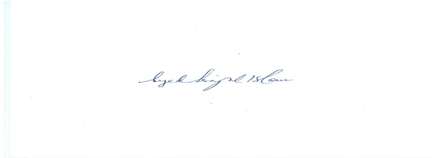

Syed Serajul Islam,
Professor and Acting Chair

