COMP 4411: Programming Languages
Department of Computer Science
Fall 2023

Instructor Information
Instructor: Dr. Sabah Mohammed, Full Professor and Professional Engineer
Office Location: AT5013
Telephone: +1 (807) 3438777
E-mail: sabah.mohammed@lakeheadu.ca
Website: https://www.lakeheadu.ca/users/M/mohammed/node/17391
Office Hours: Tuesday 11:30AM-12:30PM(Noon)

Teaching Assistant (TA) Information: TBA (An email will be send at the beginning of the term)

Course Identification
Course Number: COMP4411
Course Name: Programming Languages
Course Location: RB1022 (with D2L (for Course Materials and Assignments)
Class Times: 10:00PM-11:30AM TTH
Prerequisites: COMP 2412 Data Structures

Course Description/Overview -
This course is an introduction to the current concepts of modern programming languages, with a strong emphasis on functional, kernel and declarative programming. The course uses Kotlin as vehicle for teaching these concepts, but the real intent is to teach enough about using these concepts to make you more effective programmer in any language -- and in learning new ones. The course is divided into two parts: Part A and Part B, where Kotlin will be used in part A to explore declarative and functional concepts along with Python and Julia. In part B, Clojure will be used to develop effective applications based on these discovered concepts which can connect to the JVM, .NET or the Web.

Calendar_Link: http://csdc.lakeheadu.ca/Catalog/ViewCatalog.aspx?pageid=viewcatalog&topicgroupid=26623&entitytype=CID&entitycode=Computer+Science+4411&loaduseredits=True

By the end of this course, students will be able to:
- Improve the background for choosing appropriate programming languages for certain classes of programming problems
- Be able in principle to program in an imperative (or procedural), an object-oriented, a functional, and a logical programming language
- Increase the ability to learn new programming languages
- Increase the capacity to express programming concepts and choose among alternative ways to express things
- Simulate useful features in languages that lack them
- Be able in principle to design a new programming language
- Carry out a research and applicable projects and present them at the class

Course Resources
Course Website()
- myCourseLink (D2L)
- Kotlin (https://kotlinlang.org/)
- Clojure (https://github.com/oakes/Nightcode)

Required Course Text(s)
- Kotlin in Action, Dmitry Jemerov and Svetlana Isakova, Manning Publications, February 2017 ISBN 9781617293290
- The Joy of Clojure 2nd E by Michael Fogus and Chris Houser, Manning Publications, 2014, ISBN: 978-1617291418

Virtual Lab:
You may like to use the university virtual lab for your programming: http://lakeheadu.ca/labs.

Course Schedule/Outline
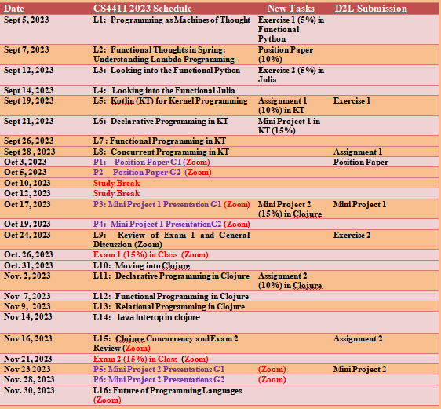

Assignments and Evaluations

Item | Date(s) | Value
Assignments | See Schedule | 20%
Exercises | See Schedule | 10%
Position Papers | See Schedule | 10%
Projects (Presentations 5% + Programming 10% for Each Project) | See Schedule and You will present your project s using Zoom (10Min) | 30%
Mid-Term Online Exam 1 | Zoom + D2L will be used- More Instructions to Follow (See Schedule)- Show Your Student ID | 15%
Mid-Term Online Exam 2 | Zoom + D2L will be used- More Instructions to Follow (See Schedule)-Show Your Student ID | 15%
Final Examination | No Final Exam
Class attendance/participation | Zoom Attendance | 5% Bonus
Total |  | 100 +5

Late Assignments
Late assignments will be deducted 1 Mark for each 1hour delay and up to 3hrs. After the three hours late assignments will automatically receive a 0 mark.

Assignments/Exercise/Projects
Detailed descriptions of the course tasks will provided at your D2L. Please see the course schedule for the time these tasks will appear at the D2L and for the due dates for submitting them.

Course Policies
My expectations for our course policies are as follows:
- Student should follow the behavioral standards (https://www.lakeheadu.ca/students/student-life/student-conduct/academic-integrity/node/51239)
- Zoom Attendance is highly encouraged,
- Office Hourse via D2L Chat at the specified time (See above).

Academic Integrity Statement:
I understand and agree that:

(1) Unless otherwise allowed by the course instructor, I must complete the assignments in this course without the assistance of anyone else.

(2) Unless otherwise allowed by the course instructor, I must not access any sources or materials (in print, online, or in any other way) to complete any course exam.

I further understand and agree that, if I violate either of these two rules, or if I provide any false or misleading information about my completion of course assignments or exams, I may be prosecuted under the Lakehead University Student Code of Conduct – Academic Integrity, which requires students to act ethically and with integrity in academic matters and to demonstrate behaviours that support the University’s academic values.

Copyright
Students should be aware that all instructional, reference, and administrative materials prepared for this course are protected in their entirety by copyright. Students are expected to comply with this copyright by only accessing and using the course materials for personal educational use related to the course, and that the materials cannot be shared in any way, without the written authorization of the course instructor. If this copyright is infringed in anyway, students may be prosecuted under the Lakehead University Student Code of Conduct – Academic Integrity, which requires students to act ethically and with integrity in academic matters and to demonstrate behaviours that support the University’s academic values.

Regulations
It is the responsibility of each student registered at Lakehead University to be familiar with, and comply with all the terms, requirements, regulations, policies and conditions in the Lakehead University Academic Calendar. This includes, but is not limited to, Academic Program Requirements, Academic Schedule of Dates, University and Faculty/School Policies and Regulations and the Fees and Refund Policies and Schedules (Lakehead University Regulations webpage, 2020-21).

Academic Integrity
A breach of Academic Integrity is a serious offence. The principle of Academic Integrity, particularly of doing one’s own work, documenting properly (including use of quotation marks, appropriate paraphrasing and referencing/citation), collaborating appropriately, and avoiding misrepresentation, is a core principle in university study. Students should view the Student Code of Conduct - Academic Integrity for a full description of academic offences, procedures when Academic Integrity breaches are suspected and sanctions for breaches of Academic Integrity.

Zoom Recording Policy
In COMP4411, in the context of remote instruction and participation, video and audio recordings of class activities will be made to ensure students' and instructors' easy and comprehensive access to those activities. The recordings are confidential and are intended only for the use of the course students and instructors. They may otherwise not be used or disclosed. During recording, to protect others' privacy, each student should ensure that no one else is present in the location where they are being recorded without that non-student's consent. The recordings are made under the authority of sections 3 and 14 of The Lakehead University Act, 1965. Questions about the collection of the images and sounds in the recordings may be directed to Dr. V. Mago.

Supports for Students – there are many resources available to support students. These include but are not limited to:
- Health and Wellness
- Student Success Centre
- Student Accessibility Centre
- Library
- Lakehead International
- Indigenous Initiatives
Lakehead University is committed to achieving full accessibility for persons with disabilities. Part of this commitment includes arranging academic accommodations for students with disabilities and/or medical conditions to ensure they have an equitable opportunity to participate in all of their academic activities. If you are a student with a disability and think you may need accommodations, you are strongly encouraged to contact Student Accessibility Services (SAS) and register as early as possible. For more information, please contact Student Accessibility Services (SC0003, 343-8047 or sas@lakeheadu.ca)

Mental Health Help

All of us can benefit from support during times of struggle. If you or anyone you know experiences academic stress, difficult life events or feelings of anxiety or depression, Student Health and Wellness is here to help. Their services are free for Lakehead Students and appointments are available. You can learn more about confidential mental health services available on and off campus at lakeheadu.ca/shw

