Practical DNA Training Program Application Instructions:

Personal Information: Be sure to complete the personal information section including your name, address, phone number and email. If you are currently staying in residence at your university, you may want to include a more permanent address (i.e. parent’s home, etc.) as course items are mailed to you following the completion of the program. Please note that the bulk of program correspondence will be delivered to you through email so be sure the email address you indicate is one that you check regularly.

Education: Include your current educational pursuits and indicate what year of the program you are currently in. Include other educational information as well (i.e. previous degrees, diplomas and other related courses.)

Program Fees: A deposit of $500.00 CAD is required immediately to guarantee your spot in the course. The balance of the course fee is due and payable two weeks before the course start date.

Payment Options: Indicate how you will be paying– credit card or certified cheque or money order. For credit cards, circle the card type (VISA or MasterCard), provide the credit card number, expiry date and the name of the cardholder as it appears on the card. For certified cheques or money orders, make them payable to Lakehead University. All fees are payable in Canadian Dollars. We are unable to accept uncertified personal cheques.

Accommodations: You are responsible for your own accommodations.

Submission Choices: You can email, fax or mail in your registration. If you are paying by certified cheque or money order, your only option is to mail in your forms and payment. Follow the instructions on the form to forward your application and deposit to us.

Contact Information: If you have any questions or concerns, please do not hesitate to contact Stephen Fratpietro at the Paleo-DNA Laboratory at 807-343-8892 or toll free in the US and Canada at 1-866-DNA-LABS.

Practical DNA Training

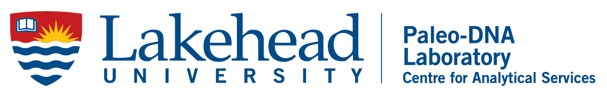
Lakehead University Paleo-DNA Laboratory

Program Date: June 15 – 25, 2020

Personal Information:
Name: |  |  |  |  | Sex: M or F
Address: |  |  | City:
Prov./State: | Country: |  |  | Postal/Zip Code:
Contact Numbers - Home: |  |  | Work:
Email Address:

Affiliation/Institution:

Research Interests:

Where did you learn about our program?
Our Website On-Campus Flyer From a Friend Conference
Other internet site Professor or Departmental Secretary Other:
Education:
Institution: |  | Degree:
Major:

Institution: |  | Degree:
Major:
Related Courses and/or Experience:

…2

2…

Program Fees:

Fee $2,500.00 CAD (plus tax) and a certificate of completion will be issued.

The program fee must be paid in full two weeks before the course. Payment receipts will be issued by Lakehead University.

NOTE: No tax receipt can be issued for this course. Please refer to Canada Revenue Agency document http://www.cra-arc.gc.ca/E/pub/tg/p105/p105-13e.pdf for more information.

Payment Options: Please indicate your deposit payment method:

Online Payment System: When we receive your application, we will send you a link to use our online payment system. Please make sure you have provided an email address on the application form.

Certified cheque or money order made payable to Lakehead University.

Contact me for payment options.

Please return this form via one of the following methods:

- Email: swfratpi@lakeheadu.ca

- Fax: 1-807-343-8619

- Mail: Paleo-DNA Laboratory
955 Oliver Road
Thunder Bay, Ontario
Canada P7B 5E1

Contact Information: Stephen Fratpietro, Technical Manager
In Thunder Bay: (807) 343-8862
Toll Free in the US & Canada: 1-866-DNA-LABS

