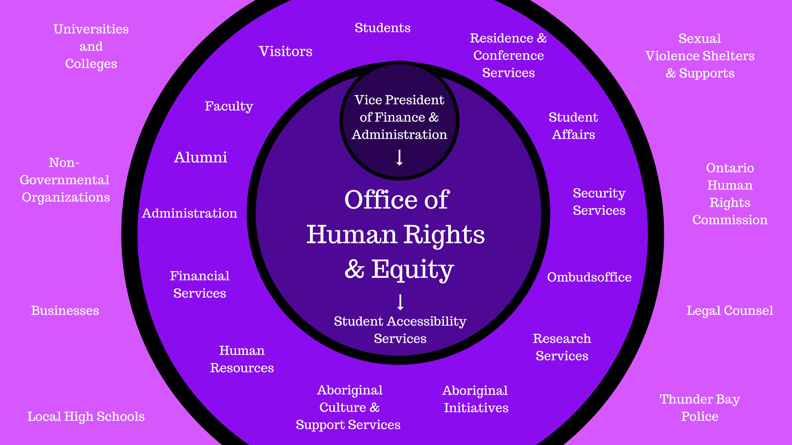

Supporting

and

University

Lakehead

to

Visitors

Students,

Employees,

Relationships

Community

The

With

Building