2027 Year 3 Undergraduate Application

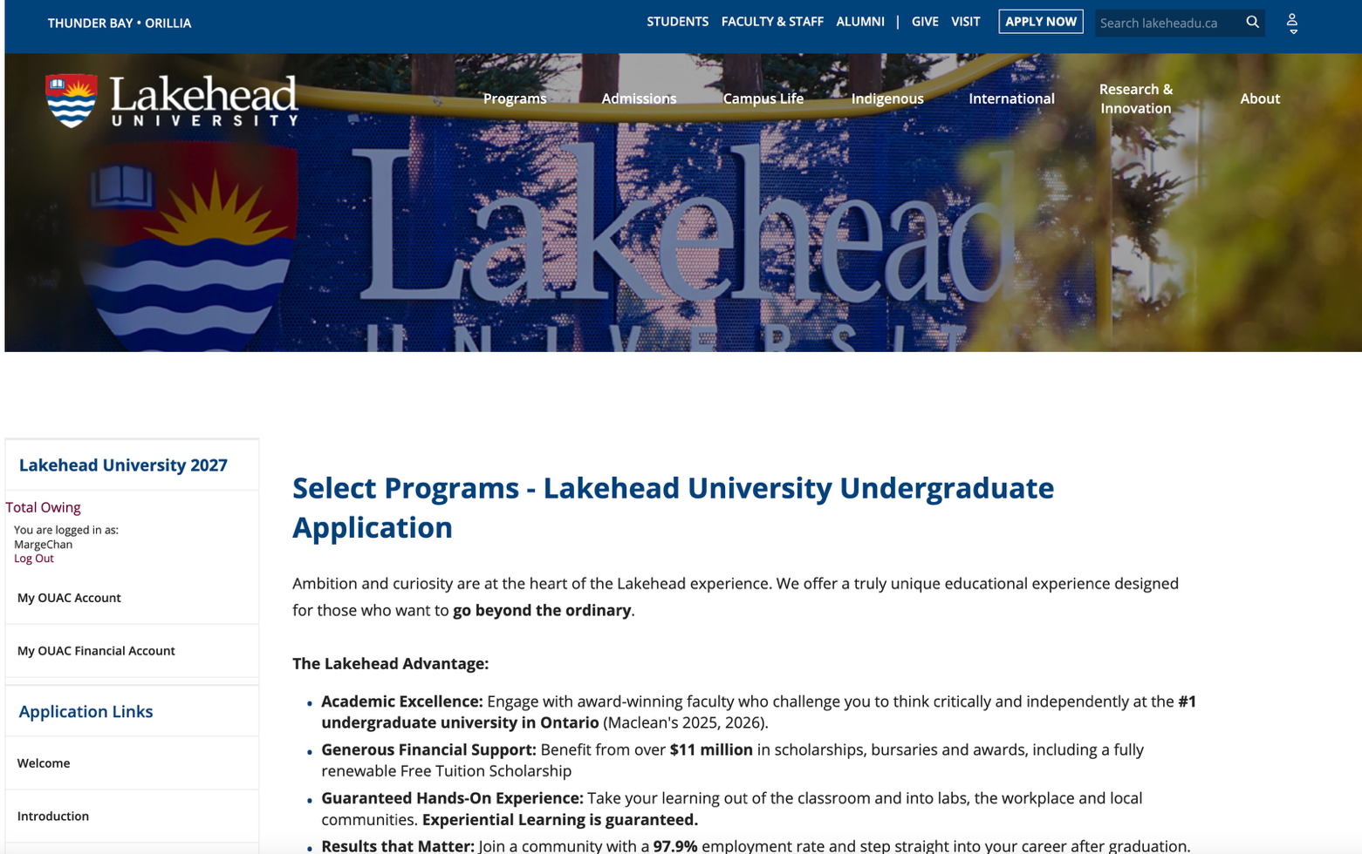

Scroll down to Degree Programs and choose Social Work (Thunder Bay & Orillia)

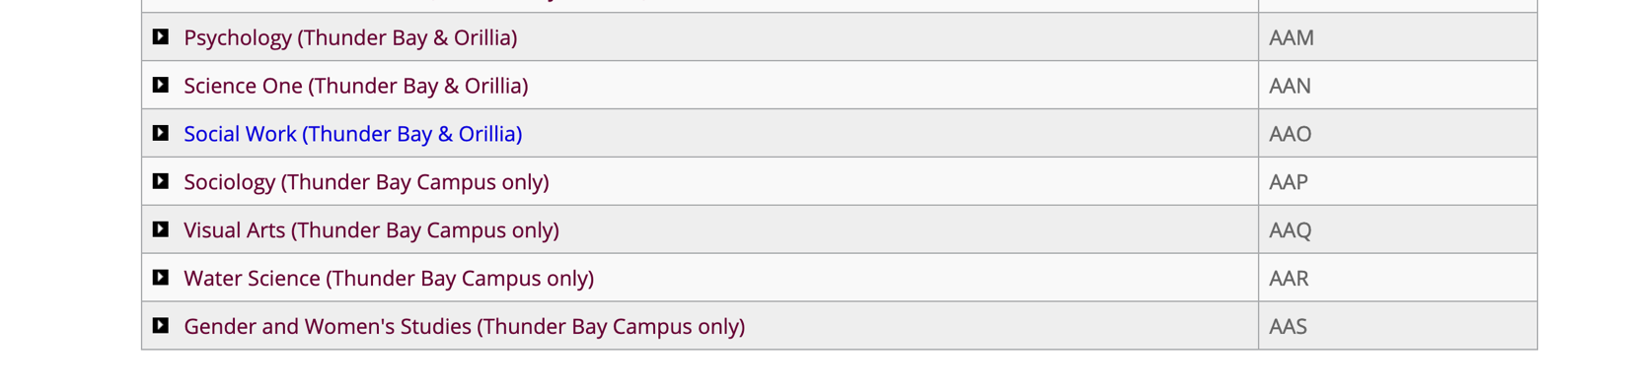

Program Details

Add Expected Date of Enrollment – 2027 Fall (September); Subject of Major Interest – either Year 3 (Orillia) or Year 3 (Thunder Bay); add Year Level – Advanced Standing and then Save Program.

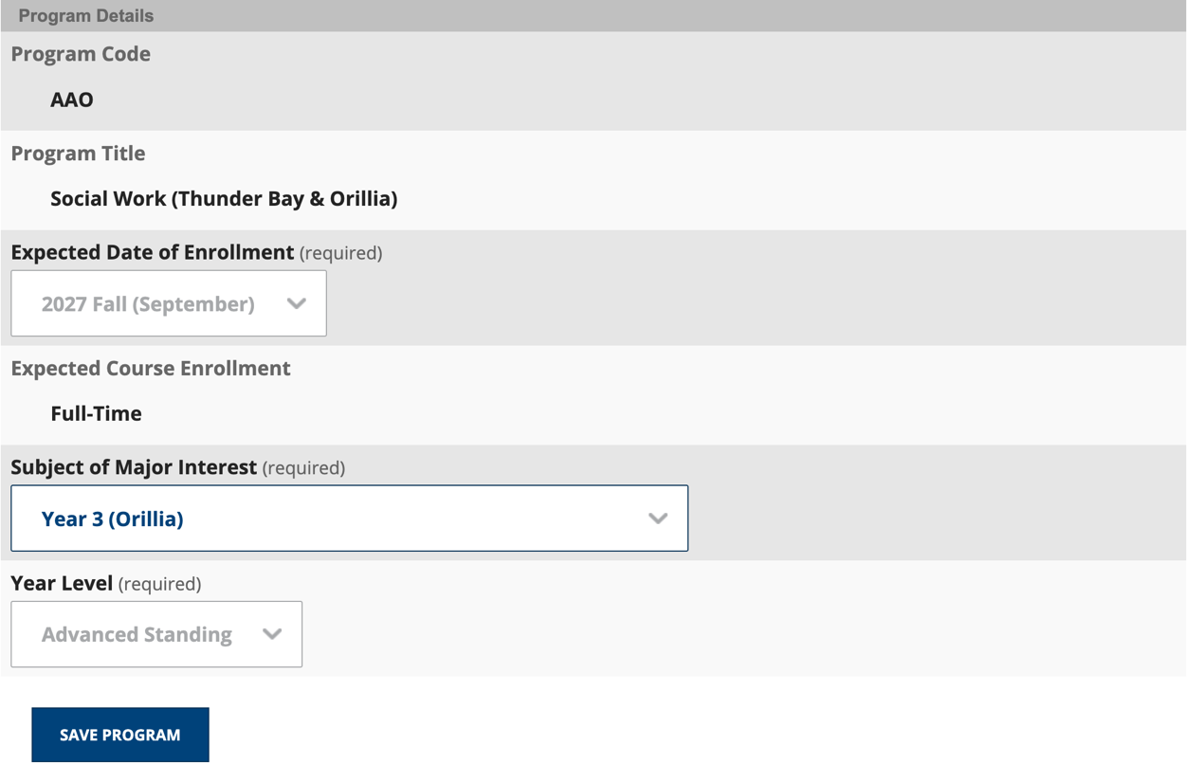

OR

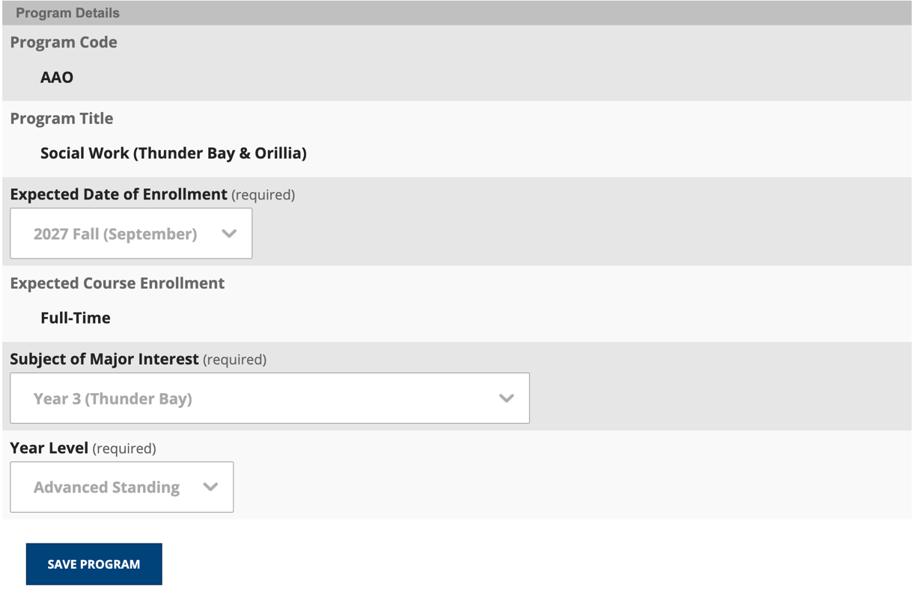

If you choose to add both Thunder Bay and Orillia you will need to Add Program.

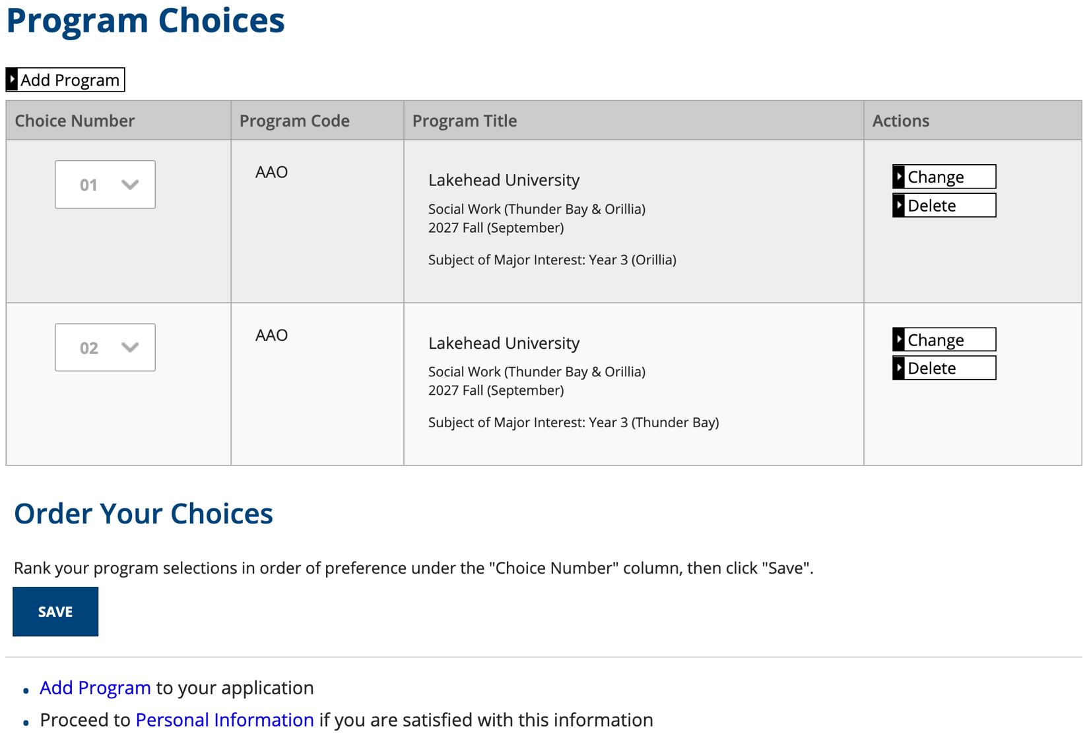
If you have added 2 program choices you will need to rank your program selections. Save and then Proceed to Personal Information.

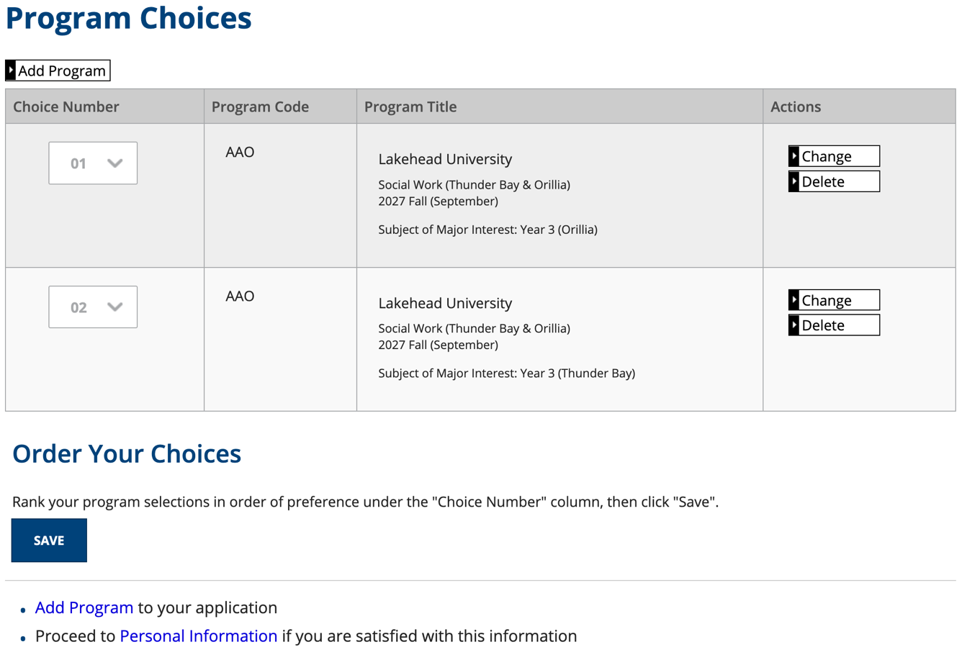

Personal Information – Add Title

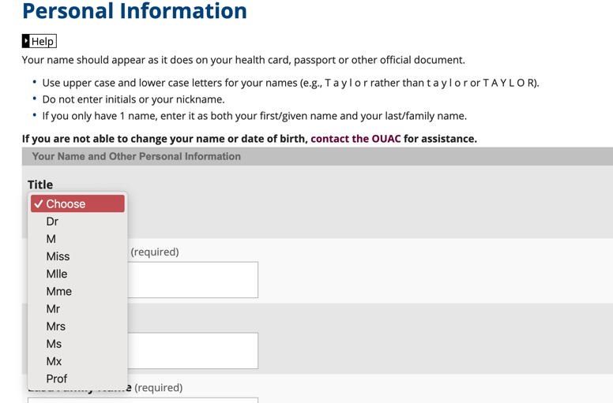

Answer all the questions and then click on SAVE AND CONTINUE. You will then need to check the information provided and if everything is correct proceed to Contact Information.

Contact Information – If your address and phone information does not show up, click on Add to add the information. Or if your email is incorrect, click on Change to make changes to it. Then Proceed to Applicant Type.

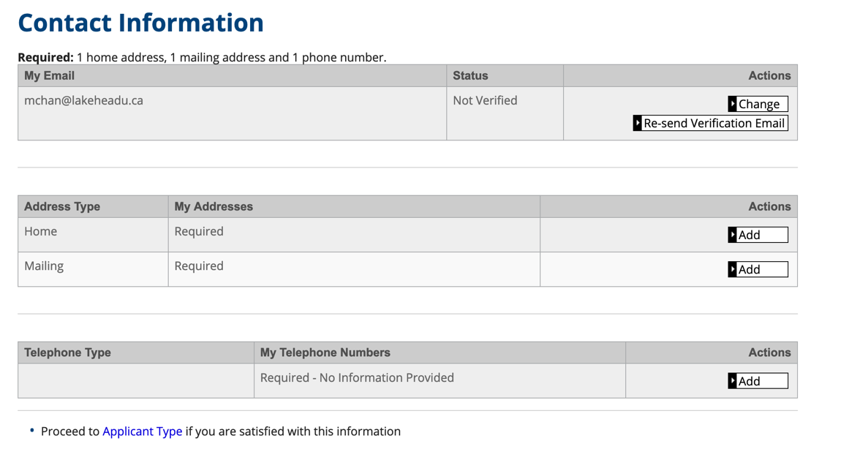

Applicant Type

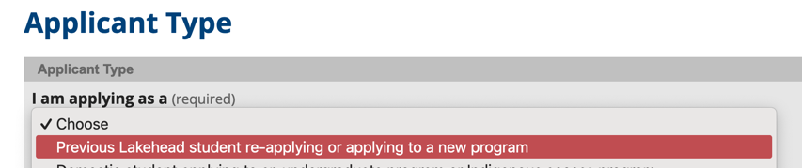

Agent Information – Choose No then skip to Previous Year Applied

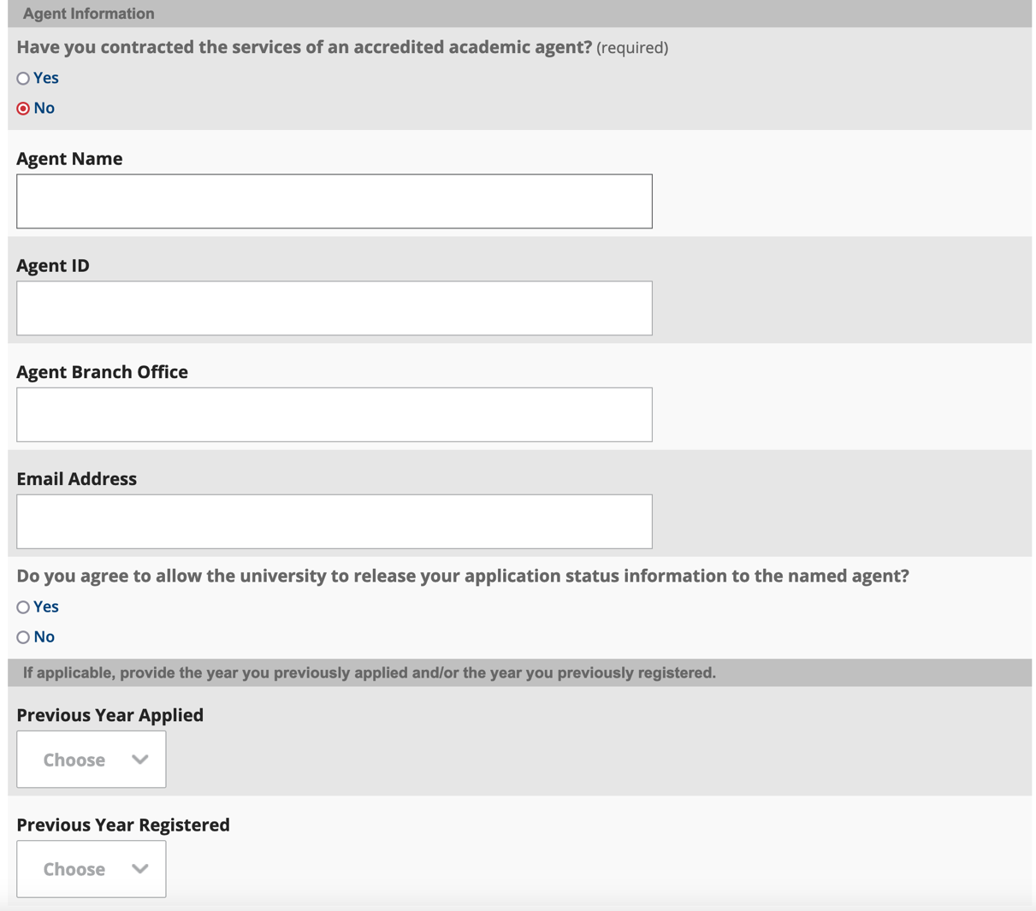

Previous Year Applied – Put the year you started at Lakehead and Previous Year Registered put this year. Then SAVE AND CONTINUE.

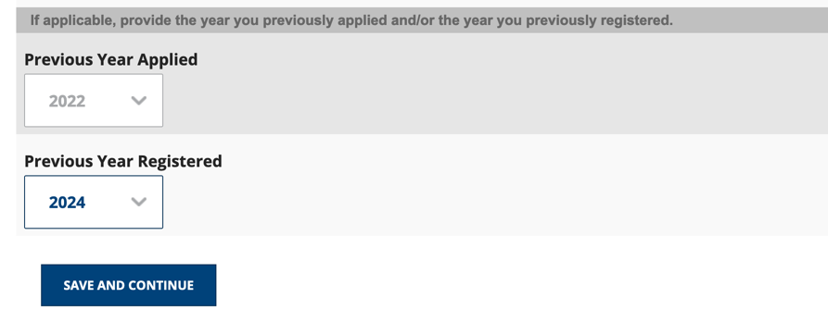

Double check all the information then proceed to Academic Background.

Academic Background – Click on Add Institution and then add Lakehead University and high school information. You cannot proceed with the application if you do not include your high school.

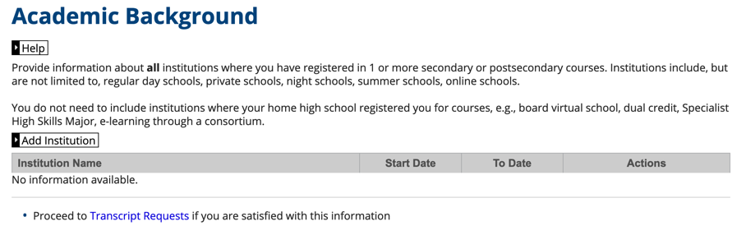

If you are listing Lakehead University, for most applicants you would be choosing 2 Year under Highest Year Level Achieved. Since most of you will be completing Year 2, you would state No to the Diploma/Degree type since you would not yet have graduated. Under Diploma/Degree Length state 4 Years then under Diploma/Degree Status choose Not Expected, the SAVE AND CONTINUE.

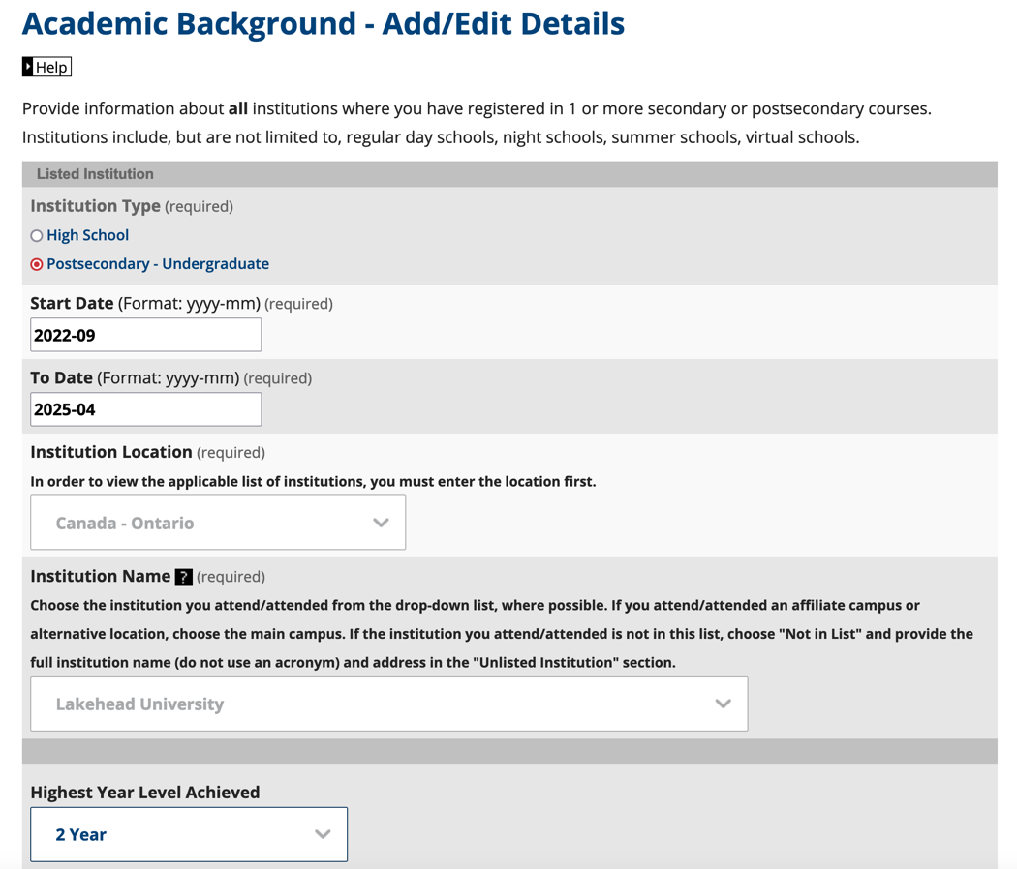

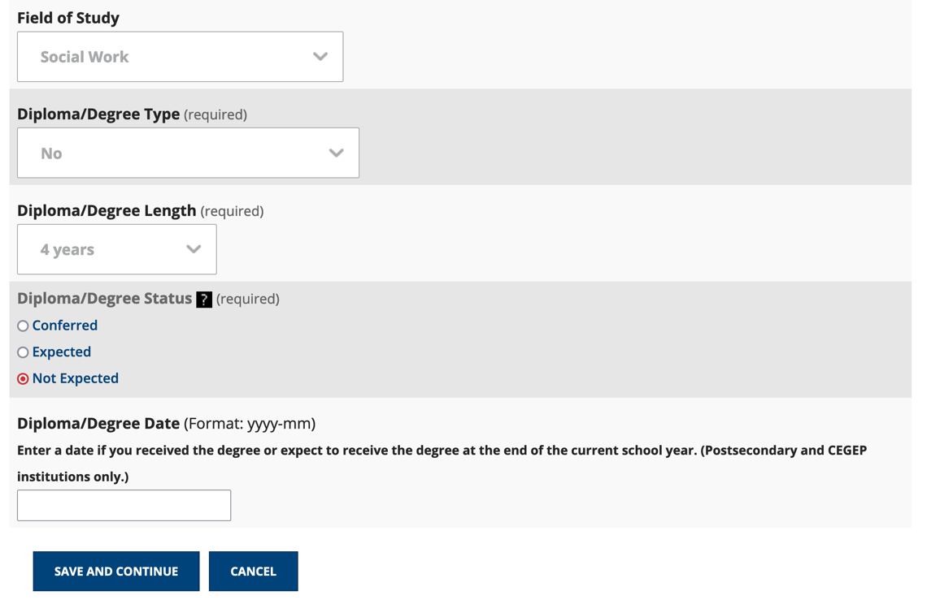

It will bring you back to Academic Background. Click on Add Institution to add your high school information.

Once you have added your high school click Save and Continue. There is no need for you to include your college as the system will automatically request an official transcript from there and there is no way to bypass that. We will already have your college marks from when you first started at Lakehead.

It will then allow you to double check your Academic Background. If no changes are required click Proceed to Transcript Requests.

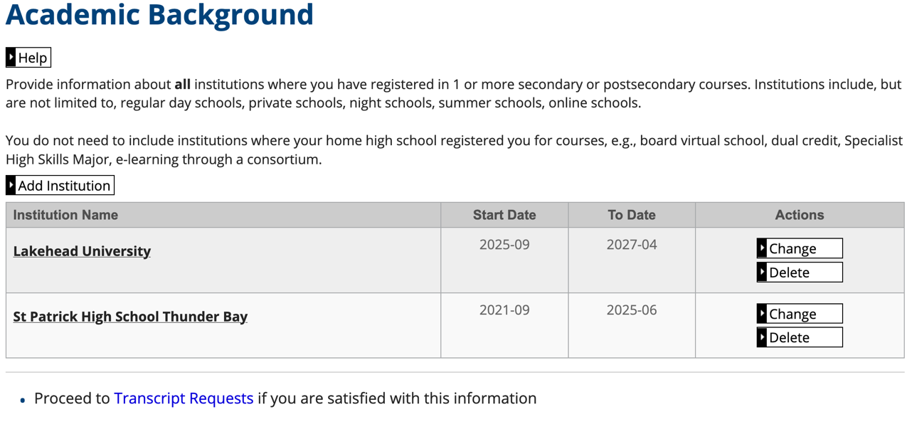
You can bypass the Transcript Requests and then click on Proceed to Review and Submit.

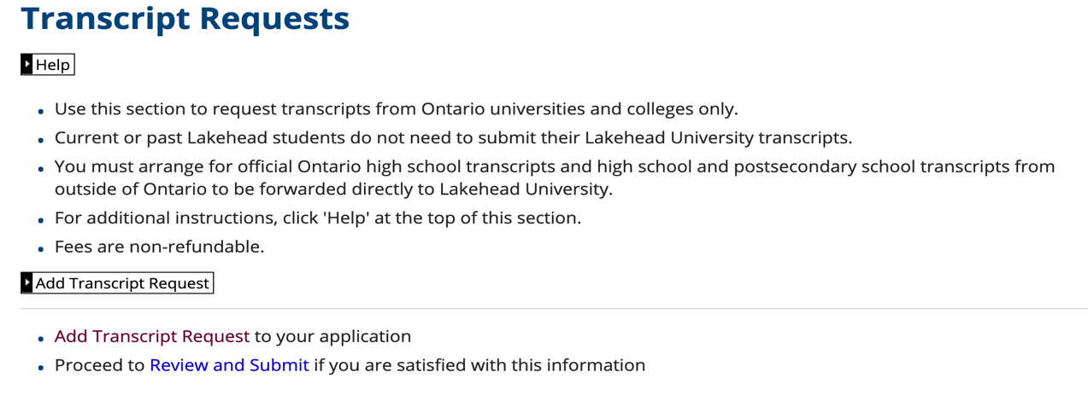

It will then bring you to a screen that allows you to double check all the information. If everything is correct you would then click on I VERIFY AND AGREE.

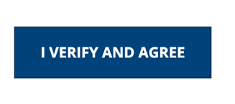
Once you have clicked on I VERIFY AND AGREE, it will then take you to the option to pay.

